A Novel Approach for Disaster Victim Detection Under Debris Environments Using Decision Tree Algorithms With Deep Learning Features
1. INTRODUCTION
Massive earthquakes, floods, plane crashes, tsunamis, and building collapses are only a few examples of the many catastrophic natural and human-caused disasters that plague the world. Disaster management is essential for reducing and avoiding the losses these catastrophes cause. Depicts the mortality statistics in building collapses caused by earthquakes and other factors worldwide over the last few years. According to the emergency relief cycle the four stages of disaster management include prevention, preparedness, reaction, and recovery. This work comes under the preparedness and reaction phases of the disaster management cycle to aid fast rescue assistance for identifying victims. This work is a continuation of our previous work as part of our motto to develop a snake-like robot for rescue assistance for human victim detection in earthquake environments. According to Urban Search And Rescue (USAR), the chances of saving a victim are only good for the first 48 hours of the rescue operation, after which the probability is almost zero. Hence, the faster the rescue mission higher the probability of saving a life. Victim identification in the collapsed building environment is one of the chief challenges for responders. One of the main concerns is the accuracy of identification. Accurately identifying victims in this situation is often difficult because of the uncertainties in the victims’ bodies and the surrounding environment. Despite these potential limitations, this work tries to identify victims using the information available to responders based on human physical anatomy. A detailed study of human identification methods is discussed in the next section. RGB and thermal image-based datasets are more useful in search and rescue scenarios involving the detection of human victims. An RGB image-based custom dataset is employed in this work for HVI in collapsed, unstructured building scenarios. Once we have a dataset, its features must be learned to identify the victim accurately. Deep learning (DL) has emerged as a powerful tool for computer vision applications, including image classification and object detection. The most common deep learning models are convolutional neural networks (CNNs), which can be applied to many data types. CNNs have become increasingly popular due to their ability to learn and extract relevant features from raw image data and classify them into different categories based on those features without manual feature engineering. CNN architecture is constituted of different layers: the input layer, convolutional layer, pooling layer, and fully connected layers are the main types of layers used in CNN. The input layer takes in a set of images and runs them through a series of convolutional layers to extract features. Each layer of a CNN typically takes as input a 4D array. The convolutional layer, the first layer in a CNN, uses filters to scan over the input data to detect features or patterns such as edges, corners, and other relevant information. The pooling layer, which follows the convolutional layer, down-samples the output from the convolutional layers by taking the maximum or average value within a specific window size, reducing the spatial dimensions of the data while preserving important information. Finally, the output of the convolutional and pooling layers is flattened into a 1D array that serves as the input to the fully connected layers. The fully connected layers are the last set of layers in a CNN and are typically used for classification or regression tasks. They take in the flattened output from the previous layers and use weights to perform matrix operations that transform the input data into predictions or outputs. Other layers, such as activation, batch normalization, and dropout, can be used to improve the performance and stability of CNN. Furthermore, the arrangement and number of each type of layer can be customized to suit specific tasks and datasets, allowing for a high degree of flexibility and adaptability in designing CNN architectures. Combining these layers allows CNNs to extract features and learn patterns from large sets of images, making them powerful tools for object detection, image recognition, and more. The success of CNN in image-related tasks has led to their application in other fields, such as natural language processing, speech recognition, and even drug discovery. This highlights the versatility and potential of CNNs as a powerful tool for various applications beyond image-related tasks. However, CNN requires a large amount of labelled data to perform well. Such a large amount of data is lacking in victim identification which is necessary for a CNN training assignment. This issue can be resolved by employing Transfer Learning (TL) techniques. TL is another technique to help deep learning systems improve their accuracy. They use pre-trained models from other tasks to help improve the learning speed and the accuracy of the new model being trained. Transfer learning helps to use the knowledge gained from a model trained on a larger dataset in a task-oriented small dataset with minimal fine-tuning, as shown in Fig. 2. That is, first, the network parameters are pre-trained using the source data, followed by their application in the target domain, and finally, the network parameters are tuned for improved performance. The main benefits of TL are increased classification accuracy and accelerated training. More literature on CNN and TL is discussed in detail in the next section. When DL models learn features from complex problems at the cost of massive data and high computation time, ML models, such as decision trees, logistic regression, and support vector machines, are easier to interpret and require fewer data and computational resources to train. Therefore this paper has tried to improve the results using ML’s benefits. ML algorithms deliver extremely accurate classification results quickly and with few hardware requirements. Features extracted from the pre-trained model are used for classification with ML-based classifiers after feature selection (i.e., discarding insignificant features). Detailed literature on ML-based classifiers is provided in the next section. Therefore, this paper proposed a deep learning-based human victim identification model combined with machine learning-based classifiers, as shown in for HVI tasks in unstructured collapsed building environments. The significant features of the work are listed below.
(i) RGB-based multiclass custom human victim dataset creation.
(ii) Data augmentation and pre-processing for enlarging the size and quality of the dataset. (iii) Transfer Learning-based feature learning.
(iv) Integration of DL-based feature extraction with ML-based feature selection and classification for victim detection. Human detection using ML classifiers is a less explored area. Our proposed integration approach for human victim detection is not found anywhere in the literature. The paper is organized as follows. Section II discusses the literature related to human detection, deep learning, and ML concepts. The materials and methods used, like data acquisition, dataset creation, and work methodology, are detailed in section III, followed by the results and discussions in section IV.

1.1 Objective of the project:
Search and Rescue operations for victim identification in an unstructured collapsed building are high-risk and time-consuming. The possibility of saving a victim is high only during the first 48 hours, and then the prospect tends to zero. The faster the response and identification, the sooner the victim can be taken to medical assistance. Combining mobile robots with practical Artificial Intelligence (AI) driven Human Victim Detection (HVD) systems managed by professional teams can considerably reduce this problem. In this paper, we have developed a Transfer Learning-based Deep Learning approach to identify human victims under collapsed building environments by integrating machine learning classification algorithms. A custom-made human victim dataset was created with five class labels: head, hand, leg, upper body, and without the body. First, we extracted the class-wise features of the dataset using fine-tuning-based transfer learning on ResNet-50 deep learning model. The learned features of the model were then extracted, and then a feature selection was performed using J48 to study the impact of feature reduction in classification.
Several decision tree algorithms, including decision stump, hoeffiding tree, J48, Linear Model Tree (LMT), Random Forest, Random Tree, Representative (REP) Tree, J48 graft, and other famous algorithms like LibSVM, Logistic regression, Multilayer perceptron, BayesNet, Naive Bayes are then used to perform the classification. The classification accuracy of the abovementioned algorithms is compared to recommend the optimal approach for real-time use. The random tree approach outperformed all other tree-based algorithms with a maximum classification accuracy of 99.53% and a computation time of 0.02 seconds.
2. LITERATURE SURVEY:
‘‘A survey on snake robot locomotion,’’
Snake robots have been a topic of discussion among researchers for decades. They are potentially strong enough to bring substantial contributions to the fields which are unsafe/ narrow/ dirty/ hard reachable to human operators, such as inspections, rescue missions, fire fighting, etc. Though the inventions of the wheel and legged mechanisms are amazing, they often fail when coming to these scenarios. Terrain adaptability is the vital essence of locomotion over constrained surfaces in biological snakes. But how this natural adaptability is accomplished in snake-like robots? Therefore, this paper focuses a study on factors behind the recreation of a physical snake, like the kinematics and dynamics modelling, mechanical design, and locomotion control approaches from existing literature. With their feature comparison, the simulators available for verifying the mathematical model and the feasibility of the mechanical design are also made for researchers new to the field.
‘‘Using deep learning to find victims in unknown cluttered urban search and rescue environments,’’
Purpose of Review We investigate the first use of deep networks for victim identification in Urban Search and Rescue (USAR). Moreover, we provide the first experimental comparison of single-stage and two-stage networks for body part detection, for cases of partial occlusions and varying illumination, on a RGB-D dataset obtained by a mobile robot navigating cluttered USAR-like environments. Recent Findings We considered the single-stage detectors Single Shot Multi-box Detector, You Only Look Once, and RetinaNet and the two-stage Feature Pyramid Network detector. Experimental results show that RetinaNet has the highest mean average precision (77.66%) and recall (86.98%) for detecting victims with body part occlusions in different lighting conditions. Summary End-to-end deep networks can be used for finding victims in USAR by autonomously extracting RGB-D image features from sensory data. We show that RetinaNet using RGB-D is robust to body part occlusions and low-lighting conditions and outperforms other detectors regardless of the image input type.
‘‘Analysis and prediction of land use in Beijing–Tianjin–Hebei region: A study based on the improved convolutional neural network model,’’
During the rapid economic development of China, there are certain blind decisions made in the use of land resources, which poses a significant threat to sustainable development. With the help of the improved convolutional neural network model, this paper analyzes the land use of the Beijing-Tianjin-Hebei region of China from 1995 to 2018, and provides a prediction for 2023. The research results show that: (1) There is still much room for improvement in the land use of the Beijing-Tianjin-Hebei region, with dry land taking up the largest proportion of land in these three locations; (2) Beijing’s development has been well protected in terms of land use. It is predicted that by 2023, the proportions of its woodland, grassland, and rivers, lakes, reservoirs and ponds would increase by 0.26%, 0.30%, and 0.61%, respectively, compared with their proportion in 2018; (3) the land use type in Tianjin during the research period was generally stable. In 2018, the proportion of its woodland and grassland had increased by 1.04% and 0.61%, respectively, compared with that of 1995; and (4) many ecological and environmental problems were exposed during the construction of highways in Hebei province. The area of sand land, saline-alkali land, marshland, bare land, and bare rock areas have all increased, and their total proportion is predicted to reach 1.48% by 2023.
‘‘Feature fusion based on convolutional neural network for SAR ATR,’
In this paper, we propose a novel multi-manifold feature fusion (MMFF) based deep learning framework for automatic target recognition (ATR) in complex-valued synthetic aperture radar (SAR) images. The conventional real-valued convolutional neural networks (CNN) usually ignore the intrinsic geometry structure of complex numbers, and the existing complex- and manifold-valued CNNs are not in accordance with the multimodality of SAR images. Founded on parallel manifold convolution branches for magnitude and phase data, the proposed MMFF model takes both the underlying geometry and the multimodal information of complex-valued SAR data into consideration, to learn manifold features of military and civilian targets for recognition tasks. Besides, we investigate manifold-valued layers such as activation function and batch normalization to leverage the MMFF architecture as well as the multimodal data. We validate our methods on two public SAR datasets in single- and dual-polarization, and achieve obviously better classification performance with less model parameters, compared with previously proposed real-, complex- and manifold-valued baselines.
‘‘Multi-channel spectrograms for speech processing applications using deep learning methods,’’
Time–frequency representations of the speech signals provide dynamic information about how the frequency component changes with time. In order to process this information, deep learning models with convolution layers can be used to obtain feature maps. In many speech processing applications, the time–frequency representations are obtained by applying the short-time Fourier transform and using single-channel input tensors to feed the models. However, this may limit the potential of convolutional networks to learn different representations of the audio signal. In this paper, we propose a methodology to combine three different time–frequency representations of the signals by computing continuous wavelet transform, Mel-spectrograms, and Gammatone spectrograms and combining then into 3D-channel spectrograms to analyze speech in two different applications: (1) automatic detection of speech deficits in cochlear implant users and (2) phoneme class recognition to extract phone-attribute features. For this, two different deep learning-based models are considered: convolutional neural networks and recurrent neural networks with convolution layers.
‘‘Detection of non-stationary GW signals in high noise from Cohen’s class of time frequency representations using deep learning,’’
Analysis of non-stationary signals in a noisy environment is a challenging research topic in many fields often requiring simultaneous signal decomposition in the time and frequency domain. This paper proposes a method for the classification of noisy non-stationary time-series signals based on Cohen’s class of their time-frequency representations (TFRs) and deep learning algorithms. We demonstrated the proposed approach on the example of detecting gravitational-wave (GW) signals in intensive real-life, non-stationary, non-white, and non-Gaussian noise. For this purpose, we prepared a dataset based on the actual data from the Laser Interferometer Gravitational-Wave Observatory (LIGO) detector and the synthetic GW signals obtained by realistic simulations. Next, 12 different TFRs from Cohen’s class were calculated from the original noisy time-series data and used to train three state-of-the-art convolutional neural network (CNN) architectures: ResNet-101, Xception, and Efficient Net. The obtained classification results are compared to those achieved by the base model trained on the original time series. Analysis of the results suggests that the proposed approach combining deep CNN architectures with Cohen’s class TFRs yields high values of performance metrics and significantly improves the classification performance compared to the base model. The TFR-CNN models achieve the values of the classification accuracy of up to 97.10%, the area under the receiver operating characteristic curve (ROC AUC) of up to 0.9885, the recall of up to 95.87%, the precision of up to 99.51%, the F1 score of up to 97.03%, and the area under the precision-recall curve (PR AUC) of up to 0.9920. This classification performance is obtained on the dataset in which the signal-to-noise ratio (SNR) values of the raw, noisy time-series signals range from −123.46 to −2.27 dB. Therefore, this study suggests that using alternative TFRs of Cohen’s class can improve the deep learning-based detection of non.
3. SYSTEM ANALYSIS
3.1 EXISTING SYSTEM:
The previous section discussed that victim identification in unknown and unstructured environments is highly uncertain. Using a machine to distinguish a human body or portion from a debris environment is challenging. To detect human presence, physical characteristics such as voice, aroma, body warmth, motion, facial form, skin colour, and body shape are used . Several research teams have developed algorithms for human victim detection based on detecting these physical features in recent years. Table lists the most widely used human identification parameters with their features. Quick human body identification can be made with RGBimage datasets and standard person detection algorithms.
A cross-power spectrum technique is used by to identify voice using a microphone. CO2 sensors sense the gas emission, so the breathing pattern is identified to detect humans. However, the prolonged response time and atmospheric air quality in terms of dust, humidity, and temperature bring this option to a downside. 3D colour histogram-based skin identification is another way, but there can be drastic pixel reduction when mobile robots use them in outdoor environments as they have a relatively wide field of view.
Nevertheless, actual life victim positions are usually unpredictable and may not tend to stand up or look straight into the camera. RGB-D is more robust against illumination and texture variations.RGB and thermal image-based datasets are more useful in search and rescue scenarios involving the detection of human victims. An RGB image-based custom dataset is employed in this work to identify human victims in collapsed, unstructured building scenarios. Once we have a dataset, its features must be learned to identify the victim accurately. Deep Learning algorithms primarily used for image and video analysis can automatically detect patterns in images and classify them into different categories based on those patterns. Different deep-learning techniques for different applications are listed in Table 2, in which learning models are classified into three categories, namely Basic deep learning models (standard pre-trained networks), deep learning models (application-based models trained from scratch), and Transfer learning-based models (task-based models derived from pre-trained models). It was found that most of the deep learning-based human detection studies used bounding box-based detection methods like YOLO. However, for rescue assistance, fast determination of the presence of a victim is more important when the location of the acquisition device is obvious. Therefore, the usual classification (without the bounding box) is enough for victim detection applications.
Disadvantages:
- Feature selection is finding and selecting the most important characteristics that could help achieve the intended class forecast. The classifier’s efficiency may suffer as a result of the existence of irrelevant information that can significantly raise the estimation complexity.

- Consequently, the feature selection procedure discards characteristics that are less important to increase the classification accuracy of the classifier. Decision tree methods are frequently employed in feature selection because they reflect information effectively.

3.2 PROPOSED SYSTEM:
- The system proposed a deep learning-base human victim identification model combined with machine learning-based classifiers, as mentioned in this system, for HVI tasks in unstructured collapsed building environments.

- Creating a CNN network from scratch and training requires a sizable amount of properly labeled dataset and Such a procedure takes time and necessitates more in-depth data examination. Numerous research has shown and advised using a pre-trained network model as they have been trained on a large amount of image data and typically have better feature extraction properties.
Advantages:
(i) RGB-based multiclass custom human victim dataset creation.
(ii) Data augmentation and pre-processing for enlarging the size and quality of the dataset.
(iii) Transfer Learning-based feature learning.
(iv) Integration of DL-based feature extraction with ML-based feature selection and classification for victim detection.
Extension Concept
In propose paper author has used all traditional ML algorithms so as extension we have utilized XGBOOST algorithm which is also a tree based algorithm with multiple ESTIMATORS to tuned dataset features which can help in better prediction accuracy.
Modules:
To implement this project we have designed following modules
- Upload Victim Detection Dataset: using this module will upload dataset and then read and extract features from all images and then plot graph of different class labels found in dataset
- Features Processing & Normalization : will process each images to normalize and shuffle pixels values and then split process images into train and test where application using 80% images for training and 20% for testing
- Extract Features from ResNet50: processed images will be input to Resnet50 algorithm to extract learned features
- Features Selection Decision Tree: extracted features will be input to J48 decision tree algorithm to select relevant features
- Run SVM Algorithm: selected features will be split to train and test and then run with SVM algorithm to calculate victim detection accuracy
- Run Random Forest: will train random forest algorithm and then calculate prediction accuracy
- Run MLP Algorithm: will train MLP algorithm and then calculate prediction accuracy
- Run Extension XGBOOST: will train extension XGBOOST algorithm and then calculate prediction accuracy
- Comparison Graph: will plot comparison graph between all algorithms
- Victim Detection from Test Image: will upload test image and then ML algorithm will predict detected victim part from the image
Note: this project has lots of module so training all modules in web will consume lots of time so we develop as TKINTER GUI
3.3. PROCESS MODEL USED WITH JUSTIFICATION
SDLC (Umbrella Model):
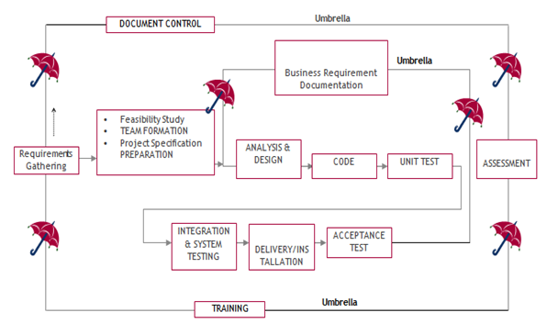
SDLC is nothing but Software Development Life Cycle. It is a standard which is used by software industry to develop good software.
Stages in SDLC:
- Requirement Gathering
- Analysis
- Designing
- Coding
- Testing
- Maintenance
Requirements Gathering stage:
The requirements gathering process takes as its input the goals identified in the high-level requirements section of the project plan. Each goal will be refined into a set of one or more requirements. These requirements define the major functions of the intended application, define operational data areas and reference data areas, and define the initial data entities. Major functions include critical processes to be managed, as well as mission critical inputs, outputs and reports. A user class hierarchy is developed and associated with these major functions, data areas, and data entities. Each of these definitions is termed a Requirement. Requirements are identified by unique requirement identifiers and, at minimum, contain a requirement title and textual description.
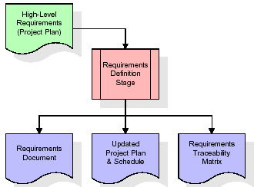
These requirements are fully described in the primary deliverables for this stage: the Requirements Document and the Requirements Traceability Matrix (RTM). The requirements document contains complete descriptions of each requirement, including diagrams and references to external documents as necessary. Note that detailed listings of database tables and fields are not included in the requirements document.
The title of each requirement is also placed into the first version of the RTM, along with the title of each goal from the project plan. The purpose of the RTM is to show that the product components developed during each stage of the software development lifecycle are formally connected to the components developed in prior stages.
In the requirements stage, the RTM consists of a list of high-level requirements, or goals, by title, with a listing of associated requirements for each goal, listed by requirement title. In this hierarchical listing, the RTM shows that each requirement developed during this stage is formally linked to a specific product goal. In this format, each requirement can be traced to a specific product goal, hence the term requirements traceability.
The outputs of the requirements definition stage include the requirements document, the RTM, and an updated project plan.
- Feasibility study is all about identification of problems in a project.
- No. of staff required to handle a project is represented as Team Formation, in this case only modules are individual tasks will be assigned to employees who are working for that project.
- Project Specifications are all about representing of various possible inputs submitting to the server and corresponding outputs along with reports maintained by administrator.
Analysis Stage:
The planning stage establishes a bird's eye view of the intended software product, and uses this to establish the basic project structure, evaluate feasibility and risks associated with the project, and describe appropriate management and technical approaches.
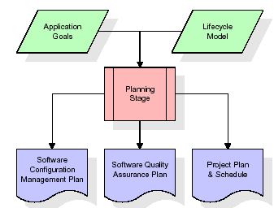
The most critical section of the project plan is a listing of high-level product requirements, also referred to as goals. All of the software product requirements to be developed during the requirements definition stage flow from one or more of these goals. The minimum information for each goal consists of a title and textual description, although additional information and references to external documents may be included. The outputs of the project planning stage are the configuration management plan, the quality assurance plan, and the project plan and schedule, with a detailed listing of scheduled activities for the upcoming Requirements stage, and high level estimates of effort for the out stages.
Designing Stage:
The design stage takes as its initial input the requirements identified in the approved requirements document. For each requirement, a set of one or more design elements will be produced as a result of interviews, workshops, and/or prototype efforts. Design elements describe the desired software features in detail, and generally include functional hierarchy diagrams, screen layout diagrams, tables of business rules, business process diagrams, pseudo code, and a complete entity-relationship diagram with a full data dictionary. These design elements are intended to describe the software in sufficient detail that skilled programmers may develop the software with minimal additional input.
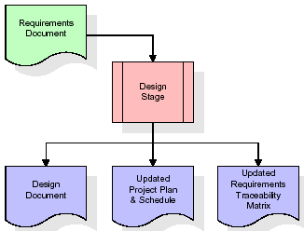
When the design document is finalized and accepted, the RTM is updated to show that each design element is formally associated with a specific requirement. The outputs of the design stage are the design document, an updated RTM, and an updated project plan.
Development (Coding) Stage:
The development stage takes as its primary input the design elements described in the approved design document. For each design element, a set of one or more software artifacts will be produced. Software artifacts include but are not limited to menus, dialogs, and data management forms, data reporting formats, and specialized procedures and functions. Appropriate test cases will be developed for each set of functionally related software artifacts, and an online help system will be developed to guide users in their interactions with the software.
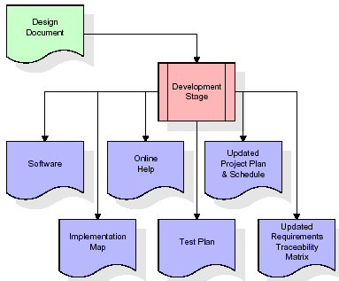

The RTM will be updated to show that each developed artifact is linked to a specific design element, and that each developed artifact has one or more corresponding test case items. At this point, the RTM is in its final configuration. The outputs of the development stage include a fully functional set of software that satisfies the requirements and design elements previously documented, an online help system that describes the operation of the software, an implementation map that identifies the primary code entry points for all major system functions, a test plan that describes the test cases to be used to validate the correctness and completeness of the software, an updated RTM, and an updated project plan.
Integration & Test Stage:
During the integration and test stage, the software artifacts, online help, and test data are migrated from the development environment to a separate test environment. At this point, all test cases are run to verify the correctness and completeness of the software. Successful execution of the test suite confirms a robust and complete migration capability. During this stage, reference data is finalized for production use and production users are identified and linked to their appropriate roles. The final reference data (or links to reference data source files) and production user list are compiled into the Production Initiation Plan.
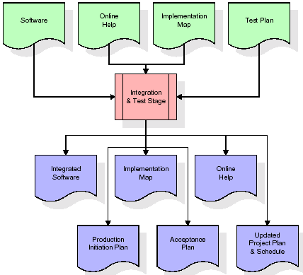
The outputs of the integration and test stage include an integrated set of software, an online help system, an implementation map, a production initiation plan that describes reference data and production users, an acceptance plan which contains the final suite of test cases, and an updated project plan.
- Installation & Acceptance Test:
During the installation and acceptance stage, the software artifacts, online help, and initial production data are loaded onto the production server. At this point, all test cases are run to verify the correctness and completeness of the software. Successful execution of the test suite is a prerequisite to acceptance of the software by the customer.
After customer personnel have verified that the initial production data load is correct and the test suite has been executed with satisfactory results, the customer formally accepts the delivery of the software.
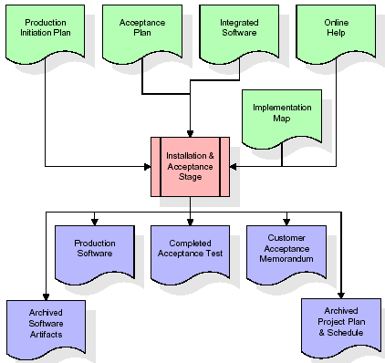
The primary outputs of the installation and acceptance stage include a production application, a completed acceptance test suite, and a memorandum of customer acceptance of the software. Finally, the PDR enters the last of the actual labor data into the project schedule and locks the project as a permanent project record. At this point the PDR "locks" the project by archiving all software items, the implementation map, the source code, and the documentation for future reference.
Maintenance:
Outer rectangle represents maintenance of a project, Maintenance team will start with requirement study, understanding of documentation later employees will be assigned work and they will undergo training on that particular assigned category. For this life cycle there is no end, it will be continued so on like an umbrella (no ending point to umbrella sticks).
3.4. Software Requirement Specification
3.4.1. Overall Description
A Software Requirements Specification (SRS) – a requirements specification for a software system is a complete description of the behaviour of a system to be developed. It includes a set of use cases that describe all the interactions the users will have with the software. In addition to use cases, the SRS also contains non-functional requirements. Non-functional requirements are requirements which impose constraints on the design or implementation (such as performance engineering requirements, quality standards, or design constraints).
System requirements specification: A structured collection of information that embodies the requirements of a system. A business analyst, sometimes titled system analyst, is responsible for analysing the business needs of their clients and stakeholders to help identify business problems and propose solutions. Within the systems development lifecycle domain, the BA typically performs a liaison function between the business side of an enterprise and the information technology department or external service providers. Projects are subject to three sorts of requirements:
- Business requirements describe in business terms what must be delivered or accomplished to provide value.
- Product requirements describe properties of a system or product (which could be one of several ways to accomplish a set of business requirements.)
- Process requirements describe activities performed by the developing organization. For instance, process requirements could specify .Preliminary investigation examine project feasibility, the likelihood the system will be useful to the organization. The main objective of the feasibility study is to test the Technical, Operational and Economical feasibility for adding new modules and debugging old running system. All system is feasible if they are unlimited resources and infinite time. There are aspects in the feasibility study portion of the preliminary investigation:
- ECONOMIC FEASIBILITY
A system can be developed technically and that will be used if installed must still be a good investment for the organization. In the economical feasibility, the development cost in creating the system is evaluated against the ultimate benefit derived from the new systems. Financial benefits must equal or exceed the costs. The system is economically feasible. It does not require any addition hardware or software. Since the interface for this system is developed using the existing resources and technologies available at NIC, There is nominal expenditure and economical feasibility for certain.
- Operational Feasibility
Proposed projects are beneficial only if they can be turned out into information system. That will meet the organization’s operating requirements. Operational feasibility aspects of the project are to be taken as an important part of the project implementation. This system is targeted to be in accordance with the above-mentioned issues. Beforehand, the management issues and user requirements have been taken into consideration. So there is no question of resistance from the users that can undermine the possible application benefits. The well-planned design would ensure the optimal utilization of the computer resources and would help in the improvement of performance status.
- TECHNICAL FEASIBILITY
Earlier no system existed to cater to the needs of ‘Secure Infrastructure Implementation System’. The current system developed is technically feasible. It is a web-based user interface for audit workflow at NIC-CSD. Thus, it provides an easy access to. the users. The database’s purpose is to create, establish and maintain a workflow among various entities in order to facilitate all concerned users in their various capacities or roles. Permission to the users would be granted based on the roles specified. Therefore, it provides the technical guarantee of accuracy, reliability and security.
3.4.2. External Interface Requirements
User Interface
The user interface of this system is a user friendly python Graphical User Interface.
Hardware Interfaces
The interaction between the user and the console is achieved through python capabilities.
Software Interfaces
The required software is python.

System Requirements:
➢ H/W System Configuration:-
➢ Processor - Pentium –IV
➢ RAM - 4 GB (min)
➢ Hard Disk - 20 GB
➢ Key Board - Standard Windows Keyboard
➢ Mouse - Two or Three Button Mouse
➢ Monitor - SVGA
SOFTWARE REQUIREMENTS:
- Operating system : Windows 7 Ultimate.
- Coding Language : Python.
- Front-End : Python.
- Back-End : Django-ORM
- Designing : Html, css, javascript.
- Data Base : MySQL (WAMP Server).
4. SYSTEM DESIGN
UML Diagram:
The Unified Modelling Language allows the software engineer to express an analysis model using the modelling notation that is governed by a set of syntactic semantic and pragmatic rules.
A UML system is represented using five different views that describe the system from distinctly different perspective. Each view is defined by a set of diagram, which is as follows.
  - User Model View
    - This view represents the system from the users perspective.
    - The analysis representation describes a usage scenario from the end-users perspective.
  - Structural Model view
    - In this model the data and functionality are arrived from inside the system.
    - This model view models the static structures.
- Behavioural Model View
It represents the dynamic of behavioural as parts of the system, depicting the interactions of collection between various structural elements described in the user model and structural model view.
- Implementation Model View
In this the structural and behavioural as parts of the system are represented as they are to be built.
- Environmental Model View
In this the structural and behavioural aspects of the environment in which the system is to be implemented are represented.
Class Diagram:
The class diagram is the main building block of object oriented modeling. It is used both for general conceptual modeling of the systematic of the application, and for detailed modeling translating the models into programming code. Class diagrams can also be used for data modeling. The classes in a class diagram represent both the main objects, interactions in the application and the classes to be programmed. In the diagram, classes are represented with boxes which contain three parts:
- The upper part holds the name of the class
- The middle part contains the attributes of the class
- The bottom part gives the methods or operations the class can take or undertake.
Use case Diagram:
A use case diagram at its simplest is a representation of a user's interaction with the system and depicting the specifications of a use case. A use case diagram can portray the different types of users of a system and the various ways that they interact with the system. This type of diagram is typically used in conjunction with the textual use case and will often be accompanied by other types of diagrams as well.
Sequence diagram:
A sequence diagram is a kind of interaction diagram that shows how processes operate with one another and in what order. It is a construct of a Message Sequence Chart. A sequence diagram shows object interactions arranged in time sequence. It depicts the objects and classes involved in the scenario and the sequence of messages exchanged between the objects needed to carry out the functionality of the scenario. Sequence diagrams are typically associated with use case realizations in the Logical View of the system under development. Sequence diagrams are sometimes called event diagrams, event scenarios, and timing diagrams.

Collaboration diagram:
A collaboration diagram describes interactions among objects in terms of sequenced messages. Collaboration diagrams represent a combination of information taken from class, sequence, and use case diagrams describing both the static structure and dynamic behaviour of a system.

Component Diagram:
In the Unified Modelling Language, a component diagram depicts how components are wired together to form larger components and or software systems. They are used to illustrate the structure of arbitrarily complex systems.
Components are wired together by using an assembly connector to connect the required interface of one component with the provided interface of another component. This illustrates the service consumer - service provider relationship between the two components.
Deployment Diagram:
A deployment diagram in the Unified Modeling Language models the physical deployment of artifacts on nodes. To describe a web site, for example, a deployment diagram would show what hardware components ("nodes") exist (e.g., a web server, an application server, and a database server), what software components ("artifacts") run on each node (e.g., web application, database), and how the different pieces are connected (e.g. JDBC, REST, RMI).
The nodes appear as boxes, and the artifacts allocated to each node appear as rectangles within the boxes. Nodes may have sub nodes, which appear as nested boxes. A single node in a deployment diagram may conceptually represent multiple physical nodes, such as a cluster of database servers.
Activity Diagram:
Activity diagram is another important diagram in UML to describe dynamic aspects of the system. It is basically a flow chart to represent the flow form one activity to another activity. The activity can be described as an operation of the system. So the control flow is drawn from one operation to another. This flow can be sequential, branched or concurrent

Upload Dataset

Preprocess Dataset
Features Extraction

Run SVM Algorithm

Run Random Forest Algorithm

Run Naive Bayes

Run XGBOOST

Run Graph

Comparison Graph

Predict From Test Data

Data Flow Diagram:
Data flow diagrams illustrate how data is processed by a system in terms of inputs and outputs. Data flow diagrams can be used to provide a clear representation of any business function. The technique starts with an overall picture of the business and continues by analyzing each of the functional areas of interest. This analysis can be carried out in precisely the level of detail required. The technique exploits a method called top-down expansion to conduct the analysis in a targeted way.
As the name suggests, Data Flow Diagram (DFD) is an illustration that explicates the passage of information in a process. A DFD can be easily drawn using simple symbols. Additionally, complicated processes can be easily automated by creating DFDs using easy-to-use, free downloadable diagramming tools. A DFD is a model for constructing and analyzing information processes. DFD illustrates the flow of information in a process depending upon the inputs and outputs. A DFD can also be referred to as a Process Model. A DFD demonstrates business or technical process with the support of the outside data saved, plus the data flowing from the process to another and the end results.
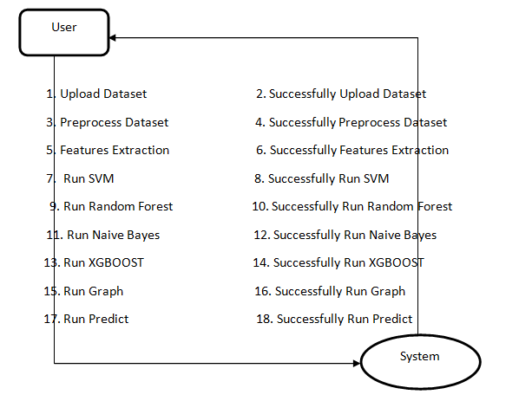
Implementation:
5.1 PYTHON
* One of the most popular languages is Python. Guido van Rossum released this language in 1991. Python is available on the Mac, Windows, and Raspberry Pi operating systems. The syntax of Python is simple and identical to that of English. When compared to Python, it was seen that the other language requires a few extra lines.
*It is an interpreter-based language because code may be run line by line after it has been written. This implies that rapid prototyping is possible across all platforms. Python is a big language with a free, binary-distributed interpreter standard library.
* It is inferior to maintenance that is conducted and is straightforward to learn. It is an object-oriented, interpreted programming language. It supports several different programming paradigms in addition to object-oriented programming, including functional and procedural programming.
* It supports several different programming paradigms in addition to object-oriented programming, including practical and procedural programming. Python is mighty while maintaining a relatively straightforward syntax. Classes, highly dynamic data types, modules, and exceptions are covered. Python can also be utilised by programmes that require programmable interfaces as an external language.
Here are some key features and characteristics of Python:
- Readability: Python emphasizes code readability with its clean and intuitive syntax. It uses indentation and whitespace to structure code blocks, making it easy to understand and maintain.
- Easy to Learn: Python's simplicity and readability make it an excellent choice for beginners. Its straightforward syntax and extensive documentation make it accessible for newcomers to programming.
- Interpreted Language: Python is an interpreted language, meaning that it doesn't need to be compiled before running. The Python interpreter reads and executes the code directly, making the development process faster and more interactive.
- Cross-platform Compatibility: Python is available for major operating systems like Windows, macOS, and Linux. This cross-platform compatibility allows developers to write code once and run it on different platforms without modifications.
- Large Standard Library: Python comes with a vast standard library that provides ready-to-use modules and functions for various tasks. It covers areas such as file I/O, networking, regular expressions, databases, and more, saving developers time and effort.
- Extensible and Modular: Python supports modular programming, enabling developers to organize code into reusable modules and packages. Additionally, Python allows integrating modules written in other languages, such as C or C++, providing flexibility and performance optimizations.
- Wide Range of Libraries and Frameworks: Python has a vibrant ecosystem with numerous third-party libraries and frameworks. These libraries, such as NumPy, pandas, TensorFlow, and Django, extend Python's capabilities for specific domains, making it a powerful tool for diverse applications.
- Object-Oriented: Python supports object-oriented programming (OOP) principles, allowing developers to create and work with classes and objects. OOP provides a structured approach to code organization, promoting code reuse and modularity.
- Dynamic Typing: Python is dynamically typed, meaning variable types are determined at runtime. Developers do not need to declare variable types explicitly, which enhances flexibility and simplifies code writing.
5.2 Installation
To install Python on your computer, follow these basic steps:
- Step 1: Visit the Python website Go to the official Python website at https://www.python.org/.
- Step 2: Select the operating system Choose the appropriate installer for your operating system. Python supports Windows, macOS, and various Linux distributions. Make sure to select the correct version that matches your operating system.
- Step 3: Check which version of Python is installed; if the 3.7.0 version is not there, uninstall it through the control panel and
- Step 4: Install Python 3.7.0 using Cmd.
- Step 5: Install the all libraries that required to run the project
- Step 6: Run
5.3 Python Features:
- Easy: Because Python is a more accessible and straightforward language, Python programming is easier to learn.
- Interpreted language: Python is an interpreted language, therefore it can be used to examine the code line by line and provide results.
- Open Source: Python is a free online programming language since it is open-source.
- Portable: Python is portable because the same code may be used on several computer standard
- libraries: Python offers a sizable library that we may utilize to create applications quickly.
- GUI: It stands for GUI (Graphical User Interface)
- Dynamical typed: Python is a dynamically typed language, therefore the type of the value will be determined at runtime.
5.4 Python GUI (Tkinter)
- Python provides a wide range of options for GUI development (Graphical User Interfaces).
- Tkinter, the most widely used GUI technique, is used for all of them.
- The Tk GUI toolkit offered by Python is used with the conventional Python interface.
- Tkinter is the easiest and quickest way to write Python GUI programs.
- Using Tkinter, creating a GUI is simple.
- A part of Python's built-in library is Tkinter. The GUI programs were created.
- Python and Tkinter together give a straightforward and quick way. The Tk GUI toolkit's object-oriented user interface is called Tkinter.

Making a GUI application is easy using Tkinter. Following are the steps:
1) Install the Tkinter module in place.
2) The GUI applicatioMakeske the primary window
3) Include one or more of the widgets mentioned above in the GUI application.
4) Set up the main event loop such that it reacts to each user-initiated event.
Although Tkinter is the only GUI framework included in the Python standard library, Python includes a GUI framework. The default library for Python is called Tkinter. Tk is a scripting language often used in designing, testing, and developing GUIs. Tk is a free, open-source widget toolkit that may be used to build GUI applications in a wide range of computer languages.
5.5 Python IDLE
- Python IDLE offers a full-fledged file editor, which gives you the ability to write and execute Python programs from within this program. The built-in file editor also includes several features, like code completion and automatic indentation, that will speed up your coding workflow.
- Guido Van Rossum named Python after the British comedy group Monty Python while the name IDLE was chosen to pay tribute to Eric Idle, who was one of the Monty Python's founding members. IDLE comes bundled with the default implementation of the Python language since the 01.5. 2b1 release
- IDLE is used to execute statements similar to Python Shell. IDLE is used to create, modify, and execute Python code. IDLE provides a fully-featured text editor to write Python scripts and provides features like syntax highlighting, auto-completion, and smart indent.
- IDLE has two modes: interactive and script. We wrote our first program, “Hello, World!” in interactive mode. Interactive mode immediately returns the results of commands you enter into the shell. In script mode, you will write a script and then run it.
- The IDE Python IDLE is a good place to start as it helps you become familiar with the way Python works and understand its syntax. This IDE is good to start programming in Python due to its great debugger, but once you are fluent and start developing projects it is necessary to jump to another, more complete IDE.
- Python IDLE (Integrated Development and Learning Environment) is an interactive development environment included with the Python programming language. It provides a convenient way to write, execute, and debug Python code.
When you install Python, IDLE is typically installed along with it. To open IDLE, you can follow these steps:
- Open the command prompt (Windows) or terminal (macOS/Linux).
- Type "idle" and press Enter. Alternatively, you can specify the version with "idle3" or "idle2" for Python 3 or Python 2, respectively.
- Once IDLE is launched, you will see the Python shell, which is an interactive environment where you can type and execute Python code directly.
Here are some features and functionalities provided by Python IDLE:
- Editor: IDLE includes a text editor where you can write your Python code. It offers syntax highlighting, automatic indentation, and code completion to enhance your coding experience.
- Interactive Shell: The Python shell in IDLE allows you to execute Python code interactively. You can type commands, statements, or function calls directly in the shell, and Python will execute them immediately.
- Debugging: IDLE provides basic debugging capabilities to help you find and fix errors in your code. You can set breakpoints, step through code, inspect variables, and track the program's execution.
- Python Help: IDLE provides access to the Python documentation and built-in help. You can access the help menu to find information about Python modules, functions, classes, and more.
- Script Execution: In addition to the interactive shell, IDLE allows you to run Python scripts stored in files. You can write your code in the editor and execute it as a script to see the output or interact with the program.
- Customization: IDLE can be customized to suit your preferences. You can modify settings related to syntax highlighting, indentation, fonts, and more.
- Python IDLE serves as a beginner-friendly development environment and learning tool. It is suitable for writing small scripts, testing code snippets, experimenting with Python features, and learning the language's basics. However, for more advanced development projects, you may consider using other code editors or integrated development environments (IDEs) that provide additional features and better project management capabilities.
5.6 Libraries
In Python, libraries (also referred to as modules or packages) are collections of pre-written code that provide additional functionality and tools to extend the capabilities of the Python language. Libraries contain reusable code that developers can leverage to perform specific tasks without having to write everything from scratch.
Python libraries are designed to solve common problems, such as handling data, performing mathematical operations, interacting with databases, working with files, implementing networking protocols, creating graphical user interfaces (GUIs), and much more. They provide ready-to-use functions, classes, and methods that simplify complex operations and save development time.
Libraries in Python offer various advantages:
- Code Reusability:
- Efficiency:
- Collaboration
- Domain-Specific Functionality
- To use a Python library, you need to install it first.
There are some libraries following:
- Pandas:
Pandas are a Python computer language library for data analysis and manipulation. It offers a specific operation and data format for handling time series and numerical tables. It differs significantly from the release3-clause of the BSD license. It is a well-liked open-source of opinion that is utilized in machine learning and data analysis.
Pandas are a Python package providing fast, flexible, and expressive data structures designed to make working with “relational” or “labeled” data both easy and intuitive. It aims to be the fundamental high-level building block for doing practical, real-world data analysis in Python. Pandas are a Python library used for working with data sets.
- It has functions for analysing, cleaning, exploring, and manipulating data.
- The name "Pandas" has a reference to both "Panel Data", and "Python Data Analysis" and was created by Wes McKinney in 2008.
- Pandas allow us to analyse big data and make conclusions based on statistical theories.
- Pandas can clean messy data sets, and make them readable and relevant.
Relevant data is very important in data science. Pandas are a Python library for data analysis. Started by Wes McKinney in 2008 out of a need for a powerful and flexible quantitative analysis tool, pandas have grown into one of the most popular Python libraries. It has an extremely active community of contributors. The name is derived from the term "panel data", an econometrics term for data sets that include observations over multiple time periods for the same individuals. Its name is a play on the phrase "Python data analysis" itself.
- NumPy:
The NumPy Python library for multi-dimensional, big-scale matrices adds a huge number of high-level mathematical functions. It is possible to modify NumPy by utilizing a Python library. Along with line, algebra, and the Fourier transform operations, it also contains several matrices-related functions.
NumPy can be used to perform a wide variety of mathematical operations on arrays. It adds powerful data structures to Python that guarantee efficient calculations with arrays and matrices and it supplies an enormous library of high-level mathematical functions that operate on these arrays and matrices.
- NumPy is a Python library used for working with arrays.
- It also has functions for working in domain of linear algebra, Fourier transform, and matrices.
- NumPy was created in 2005 by Travis Oliphant. It is an open source project and you can use it freely.
- NumPy stands for Numerical Python.
- In Python we have lists that serve the purpose of arrays, but they are slow to process.
- NumPy aims to provide an array object that is up to 50x faster than traditional Python lists.
- The array object in NumPy is called ndarray, it provides a lot of supporting functions that make working with ndarray very easy.
- Arrays are very frequently used in data science, where speed and resources are very important.

- Matplotlib:
It is a multi-platform, array-based data visualization framework built to interact with the whole SciPy stack. MATLAB is proposed as an open-source alternative. Matplotlib is a Python extension and a cross-platform toolkit for graphical plotting and visualization.
Matplotlib is a popular Python library for creating static, animated, and interactive visualizations. It provides a flexible and comprehensive set of tools for generating plots, charts, histograms, scatter plots, and more. Matplotlib is widely used in various fields, including data analysis, scientific research, and data visualization.
Here are some key features and functionalities of the Matplotlib library:
- Plotting Functions
- Customization Options
- Multiple Interfaces
- Integration with NumPy and pandas
- Subplots and Figures:
- Saving and Exporting

- Scikit-learn:
The most stable and practical machine learning library for Python is scikit-learn. Regression, dimensionality reduction, classification, and clustering are just a few of the helpful tools it provides through the Python interface for statistical modeling and machine learning. It is an essential part of the Python machine learning toolbox used by JP Morgan. It is frequently used in various machine learning applications, including classification and predictive analysis.
Scikit-learn (also referred to as sklearn) is a widely used open-source machine learning library for Python. It provides a comprehensive set of tools and algorithms for various machine learning tasks, including classification, regression, clustering, dimensionality reduction, model selection, and pre-processing.
Here are some key features and functionalities of the Scikit-learn library:
- Easy-to-Use Interface:
- Broad Range of Algorithms:
- Data Pre-processing and Feature Engineering:
- Model Evaluation and Validation:
- Integration with NumPy and pandas:
- Robust Documentation and Community Support:

- Keras:
* Google's Keras is a cutting-edge deep learning API for creating neural networks. It is created in Python and is designed to simplify the development of neural networks. Additionally, it enables the use of various neural networks for computation. Deep learning models are developed and tested using the free and open-source Python software known as Keras.
Keras is a high-level deep learning library for Python. It is designed to provide a user-friendly and intuitive interface for building and training deep learning models. Keras acts as a front-end API, allowing developers to define and configure neural networks while leveraging the computational backend engines, such as Tensor Flow or Theano.
Here are some key features and functionalities of the Keras library:
- User-Friendly API
- Multi-backend Support
- Wide Range of Neural Network Architectures
- Pre-trained Models and Transfer Learning:
- Easy Model Training and Evaluation:
- GPU Support:

- h5py:
* The h5py Python module offers an interface for the binary HDF5 data format. Thanks to p5py, the top can quickly halt the vast amount of numerical data and alter it using the NumPy library. It employs common syntax for Python, NumPy, and dictionary arrays.
h5py is a Python library that provides a simple and efficient interface for working with datasets and files in the Hierarchical Data Format 5 (HDF5) format. HDF5 is a versatile data format commonly used for storing and managing large volumes of numerical data.
Here are some key features and functionalities of the h5py library:
  - HDF5 File Access
  - Dataset Handling:
  - Group Organization:
  - Attributes:
  - Compatibility with NumPy
  - Performance

- Tensor flow
TensorFlow is a Python library for fast numerical computing created and released by Google. It is a foundation library that can be used to create Deep Learning models directly or by using wrapper libraries that simplify the process built on top of TensorFlow. TensorFlow is an end-to-end open source platform for machine learning. TensorFlow is a rich system for managing all aspects of a machine learning system; however, this class focuses on using a particular TensorFlow API to develop and train machine learning models.
TensorFlow is a popular open-source library for machine learning and deep learning. It provides a comprehensive set of tools, APIs, and computational resources for building and training various types of machine learning models, especially neural networks.
Here are some key features and functionalities of TensorFlow:
- Neural Network Framework:
- Computational Graphs
- Automatic Differentiation
- GPU and TPU Support
- Distributed Computing
- Deployment Capabilities

- Tkinter
Tkinter is an acronym for "Tk interface". Tk was developed as a GUI extension for the Tcl scripting language by John Ousterhout. The first release was in 1991. Tkinter is the de facto way in Python to create Graphical User interfaces (GUIs) and is included in all standard Python Distributions. In fact, it's the only framework built into the Python standard library.
Tkinter is a standard Python library used for creating graphical user interfaces (GUIs). It provides a set of modules and classes that allow you to develop interactive and visually appealing desktop applications.
Here are some key features and functionalities of Tkinter:
- Cross-Platform Compatibility
- Simple and Easy-to-Use
- Widgets and Layout Management
- Event-Driven Programming
- Customization and Styling
- Integration with Other Libraries

- NLTK
NLTK is a toolkit build for working with NLP in Python. It provides us various text processing libraries with a lot of test datasets. A variety of tasks can be performed using NLTK such as tokenizing, parse tree visualization, etc NLTK (Natural Language Toolkit) is the go-to API for NLP (Natural Language Processing) with Python. It is a really powerful tool to pre-process text data for further analysis like with ML models for instance. It helps convert text into numbers, which the model can then easily work with.
NLTK (Natural Language Toolkit) is a Python library widely used for working with human language data and implementing natural language processing (NLP) tasks. It provides a set of tools, corpora, and resources for tasks such as tokenization, stemming, tagging, parsing, sentiment analysis, and more.
Here are some key features and functionalities of NLTK:
- Text Processing
- Part-of-Speech Tagging
- Named Entity Recognition
- Chunking and Parsing
- Sentiment Analysis:
- WordNet Integration:

- Scipy
SciPy is a collection of mathematical algorithms and convenience functions built on the NumPy extension of Python. It adds significant power to the interactive Python session by providing the user with high-level commands and classes for manipulating and visualizing data.
SciPy is a powerful scientific computing library for Python that provides a wide range of mathematical algorithms and functions. It builds upon NumPy, another fundamental library for numerical computing, and extends its capabilities by adding additional tools for scientific and technical computing tasks.
Here are some key features and functionalities of SciPy:
- Numerical Integration:
- Optimization and Root Finding
- Linear Algebra
- Signal and Image Processing
- Statistics
Algorithm:
XGBOOST Algorithm:
XGBoost is an optimized distributed gradient boosting library designed for efficient and scalable training of machine learning models. It is an ensemble learning method that combines the predictions of multiple weak models to produce a stronger prediction. XGBoost stands for “Extreme Gradient Boosting” and it has become one of the most popular and widely used machine learning algorithms due to its ability to handle large datasets and its ability to achieve state-of-the-art performance in many machine learning tasks such as classification and regression.
One of the key features of XGBoost is its efficient handling of missing values, which allows it to handle real-world data with missing values without requiring significant pre-processing. Additionally, XGBoost has built-in support for parallel processing, making it possible to train models on large datasets in a reasonable amount of time.
XGBoost can be used in a variety of applications, including Kaggle competitions, recommendation systems, and click-through rate prediction, among others. It is also highly customizable and allows for fine-tuning of various model parameters to optimize performance.
XgBoost stands for Extreme Gradient Boosting, which was proposed by the researchers at the University of Washington. It is a library written in C++ which optimizes the training for Gradient Boosting.
Before understanding the XGBoost, we first need to understand the trees especially the decision tree:

Decision Tree:
A Decision tree is a flowchart-like tree structure, where each internal node denotes a test on an attribute, each branch represents an outcome of the test, and each leaf node (terminal node) holds a class label.
A tree can be “learned” by splitting the source set into subsets based on an attribute value test. This process is repeated on each derived subset in a recursive manner called recursive partitioning. The recursion is completed when the subset at a node all has the same value of the target variable, or when splitting no longer adds value to the predictions.

Bagging:
A Bagging classifier is an ensemble meta-estimator that fits base classifiers each on random subsets of the original dataset and then aggregate their individual predictions (either by voting or by averaging) to form a final prediction. Such a meta-estimator can typically be used as a way to reduce the variance of a black-box estimator (e.g., a decision tree), by introducing randomization into its construction procedure and then making an ensemble out of it.
Each base classifier is trained in parallel with a training set which is generated by randomly drawing, with replacement, N examples(or data) from the original training dataset, where N is the size of the original training set. The training set for each of the base classifiers is independent of each other. Many of the original data may be repeated in the resulting training set while others may be left out.
Bagging reduces overfitting (variance) by averaging or voting, however, this leads to an increase in bias, which is compensated by the reduction in variance though.

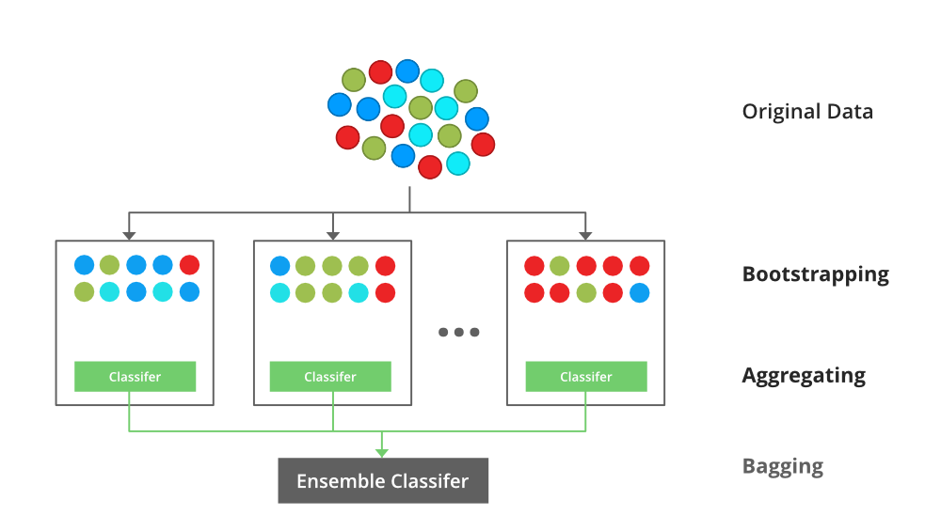

Random Forest:
Every decision tree has high variance, but when we combine all of them together in parallel then the resultant variance is low as each decision tree gets perfectly trained on that particular sample data and hence the output doesn’t depend on one decision tree but multiple decision trees. In the case of a classification problem, the final output is taken by using the majority voting classifier. In the case of a regression problem, the final output is the mean of all the outputs. This part is Aggregation.
The basic idea behind this is to combine multiple decision trees in determining the final output rather than relying on individual decision trees.rRandom Forest has multiple decision trees as base learning models. We randomly perform row sampling and feature sampling from the dataset forming sample datasets for every model. This part is called Bootstrap.

Boosting:
Boosting is an ensemble modelling, technique that attempts to build a strong classifier from the number of weak classifiers. It is done by building a model by using weak models in series. Firstly, a model is built from the training data. Then the second model is built which tries to correct the errors present in the first model. This procedure is continued and models are added until either the complete training data set is predicted correctly or the maximum number of models are added.

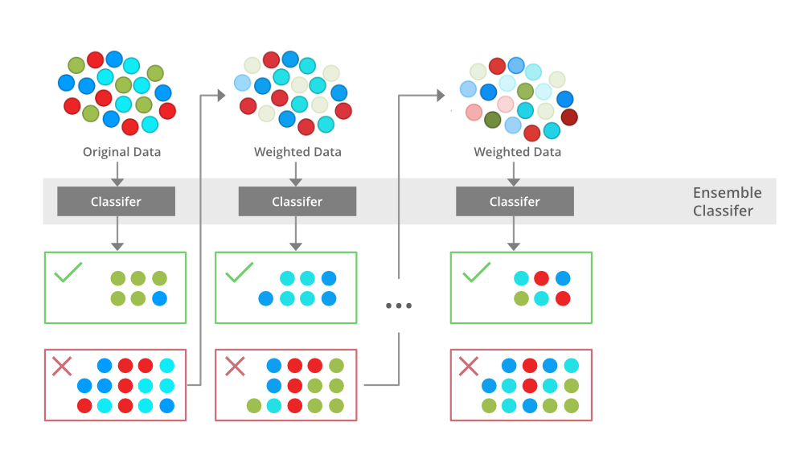

Gradient Boosting
Gradient Boosting is a popular boosting algorithm. In gradient boosting, each predictor corrects its predecessor’s error. In contrast to Adaboost, the weights of the training instances are not tweaked, instead, each predictor is trained using the residual errors of predecessor as labels.
There is a technique called the Gradient Boosted Trees whose base learner is CART (Classification and Regression Trees).

XGBoost
XGBoost is an implementation of Gradient Boosted decision trees. XGBoost models majorly dominate in many Kaggle Competitions.
In this algorithm, decision trees are created in sequential form. Weights play an important role in XGBoost. Weights are assigned to all the independent variables which are then fed into the decision tree which predicts results. The weight of variables predicted wrong by the tree is increased and these variables are then fed to the second decision tree. These individual classifiers/predictors then ensemble to give a strong and more precise model. It can work on regression, classification, ranking, and user-defined prediction problems.
Decision Tree:
Decision Tree is one of the most powerful and popular algorithms. Python Decision-tree algorithm falls under the category of supervised learning algorithms. It works for both continuous as well as categorical output variables. In this article, We are going to implement a Decision tree in Python algorithm on the Balance Scale Weight & Distance Database presented on the UCI. A Decision tree is a tree-like structure that represents a set of decisions and their possible consequences. Each node in the tree represents a decision, and each branch represents an outcome of that decision. The leaves of the tree represent the final decisions or predictions.
Decision trees are created by recursively partitioning the data into smaller and smaller subsets. At each partition, the data is split based on a specific feature, and the split is made in a way that maximizes the information gain.
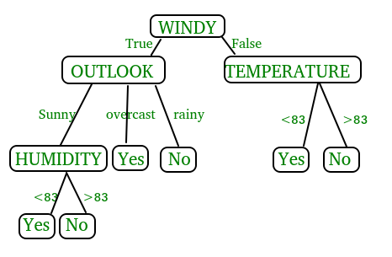
In the above figure, decision tree is a flowchart-like tree structure that is used to make decisions. It consists of Root Node(WINDY), Internal nodes(OUTLOOK, TEMPERATURE), which represent tests on attributes, and leaf nodes, which represent the final decisions. The branches of the tree represent the possible outcomes of the tests.

Key Components of Decision Trees in Python
- Root Node: The decision tree’s starting node, which stands for the complete dataset.
- Branch Nodes: Internal nodes that represent decision points, where the data is split based on a specific attribute.
- Leaf Nodes: Final categorization or prediction-representing terminal nodes.
- Decision Rules: Rules that govern the splitting of data at each branch node.
- Attribute Selection: The process of choosing the most informative attribute for each split.
- Splitting Criteria: Metrics like information gain, entropy, or the Gini Index are used to calculate the optimal split.

Assumptions we make while using Decision tree
- At the beginning, we consider the whole training set as the root.
- Attributes are assumed to be categorical for information gain and for gini index, attributes are assumed to be continuous.
- On the basis of attribute values records are distributed recursively.
- We use statistical methods for ordering attributes as root or internal node
Implementing Decision Tree Using Python:
from sklearn.datasets import load_iris
from sklearn.model_selection import train_test_split
from sklearn.tree import DecisionTreeClassifier
from sklearn.metrics import accuracy_score
# Load the Iris dataset
iris = load_iris()
X = iris.data
y = iris.target
# Split the dataset into training and testing sets
X_train, X_test, y_train, y_test = train_test_split(X, y, test_size=0.2, random_state=42)
# Initialize the decision tree classifier
clf = DecisionTreeClassifier()
# Train the classifier on the training data
clf.fit(X_train, y_train)
# Make predictions on the testing data
y_pred = clf.predict(X_test)
# Calculate the accuracy of the classifier
accuracy = accuracy_score(y_test, y_pred)
print("Accuracy:", accuracy)
In This Example :
- We first import necessary modules from scikit-learn.
- We load the Iris dataset, a popular dataset for classification tasks.
- We split the dataset into training and testing sets using the train test split function.
- We initialize a Decision Tree Classifier.
- We train the classifier on the training data using the fit method.
- We make predictions on the testing data using the predict method.
- Finally, we calculate the accuracy of the classifier using the accuracy score function.

3.Random Forest:
Machine learning, a fascinating blend of computer science and statistics, has witnessed incredible progress, with one standout algorithm being the Random Forest. Random forests or Random Decision Trees is a collaborative team of decision trees that work together to provide a single output. Originating in 2001 through Leo Breiman, Random Forest has become a cornerstone for machine learning enthusiasts. In this article, we will explore the fundamentals and implementation of Random Forest Algorithm.
Random Forest algorithm is a powerful tree learning technique in Machine Learning. It works by creating a number of Decision Trees during the training phase. Each tree is constructed using a random subset of the data set to measure a random subset of features in each partition. This randomness introduces variability among individual trees, reducing the risk of overfitting and improving overall prediction performance. In prediction, the algorithm aggregates the results of all trees, either by voting (for classification tasks) or by averaging (for regression tasks) This collaborative decision-making process, supported by multiple trees with their insights, provides an example stable and precise results. Random forests are widely used for classification and regression functions, which are known for their ability to handle complex data, reduce overfitting, and provide reliable forecasts in different environments.
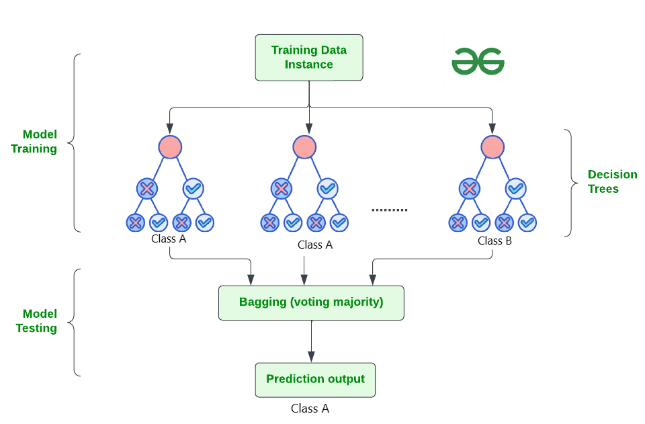

How Does Random Forest Work?
The random Forest algorithm works in several steps which are discussed below–>
- Ensemble of Decision Trees: Random Forest leverages the power of ensemble learning by constructing an army of Decision Trees. These trees are like individual experts, each specializing in a particular aspect of the data. Importantly, they operate independently, minimizing the risk of the model being overly influenced by the nuances of a single tree.
- Random Feature Selection: To ensure that each decision tree in the ensemble brings a unique perspective, Random Forest employs random feature selection. During the training of each tree, a random subset of features is chosen. This randomness ensures that each tree focuses on different aspects of the data, fostering a diverse set of predictors within the ensemble.
- Bootstrap Aggregating or Bagging: The technique of bagging is a cornerstone of Random Forest’s training strategy which involves creating multiple bootstrap samples from the original dataset, allowing instances to be sampled with replacement. This results in different subsets of data for each decision tree, introducing variability in the training process and making the model more robust.
- Decision Making and Voting: When it comes to making predictions, each decision tree in the Random Forest casts its vote. For classification tasks, the final prediction is determined by the mode (most frequent prediction) across all the trees. In regression tasks, the average of the individual tree predictions is taken. This internal voting mechanism ensures a balanced and collective decision-making process.

Key Features of Random Forest
Some of the Key Features of Random Forest are discussed below–>
- High Predictive Accuracy: Imagine Random Forest as a team of decision-making wizards. Each wizard (decision tree) looks at a part of the problem, and together, they weave their insights into a powerful prediction tapestry. This teamwork often results in a more accurate model than what a single wizard could achieve.
- Resistance to Overfitting: Random Forest is like a cool-headed mentor guiding its apprentices (decision trees). Instead of letting each apprentice memorize every detail of their training, it encourages a more well-rounded understanding. This approach helps prevent getting too caught up with the training data which makes the model less prone to overfitting.
- Large Datasets Handling: Dealing with a mountain of data? Random Forest tackles it like a seasoned explorer with a team of helpers (decision trees). Each helper takes on a part of the dataset, ensuring that the expedition is not only thorough but also surprisingly quick.
- Variable Importance Assessment: Think of Random Forest as a detective at a crime scene, figuring out which clues (features) matter the most. It assesses the importance of each clue in solving the case, helping you focus on the key elements that drive predictions.
- Built-in Cross-Validation: Random Forest is like having a personal coach that keeps you in check. As it trains each decision tree, it also sets aside a secret group of cases (out-of-bag) for testing. This built-in validation ensures your model doesn’t just ace the training but also performs well on new challenges.
- Handling Missing Values: Life is full of uncertainties, just like datasets with missing values. Random Forest is the friend who adapts to the situation, making predictions using the information available. It doesn’t get flustered by missing pieces; instead, it focuses on what it can confidently tell us.
- Parallelization for Speed: Random Forest is your time-saving buddy. Picture each decision tree as a worker tackling a piece of a puzzle simultaneously. This parallel approach taps into the power of modern tech, making the whole process faster and more efficient for handling large-scale projects.

Implement Random Forest for Classification :
# Import necessary libraries
import pandas as pd
from sklearn.model_selection import train_test_split
from sklearn.ensemble import RandomForestClassifier
from sklearn.metrics import accuracy_score, classification_report
import warnings
warnings.filterwarnings('ignore')
# Load the Titanic dataset
url = "https://raw.githubusercontent.com/datasciencedojo/datasets/master/titanic.csv"
titanic_data = pd.read_csv(url)
# Drop rows with missing target values
titanic_data = titanic_data.dropna(subset=['Survived'])
# Select relevant features and target variable
X = titanic_data[['Pclass', 'Sex', 'Age', 'SibSp', 'Parch', 'Fare']]
y = titanic_data['Survived']
# Convert categorical variable 'Sex' to numerical using .loc
X.loc[:, 'Sex'] = X['Sex'].map({'female': 0, 'male': 1})
# Handle missing values in the 'Age' column using .loc
X.loc[:, 'Age'].fillna(X['Age'].median(), inplace=True)

# Split the dataset into training and testing sets
X_train, X_test, y_train, y_test = train_test_split(X, y, test_size=0.2, random_state=42)
# Create a Random Forest Classifier
rf_classifier = RandomForestClassifier(n_estimators=100, random_state=42)
# Train the classifier
rf_classifier.fit(X_train, y_train)
# Make predictions on the test set
y_pred = rf_classifier.predict(X_test)
# Evaluate the model
accuracy = accuracy_score(y_test, y_pred)
classification_rep = classification_report(y_test, y_pred)
# Print the results
print(f"Accuracy: {accuracy:.2f}")
print("\nClassification Report:\n", classification_rep)
Output:
Accuracy: 0.80

Classification Report:
precision recall f1-score support

0 0.82 0.85 0.83 105
1 0.77 0.73 0.75 74

accuracy 0.80 179
macro avg 0.79 0.79 0.79 179
weighted avg 0.80 0.80 0.80 179

In the above code, we’re using a Random Forest Classifier to make sense of the Titanic dataset. First, we gather our tools – importing libraries to handle data and evaluate our model. Next, we dive into the Titanic dataset, fixing missing information and choosing important details like a detective solving a mystery. We even teach the computer to understand ‘male’ and ‘female’ by turning them into numbers. Then, we split our dataset into pieces – one part to train our model, and the other to test its newfound skills. Our Random Forest Classifier is like a student, learning from the training set. Once trained, it faces a test – making predictions on the test set. We’re like judges, using a classification report to grade how well our model did.
4. Support Vector Machine (SVM):
Support Vector Machine (SVM) is a powerful machine learning algorithm used for linear or nonlinear classification, regression, and even outlier detection tasks. SVMs can be used for a variety of tasks, such as text classification, image classification, spam detection, handwriting identification, gene expression analysis, face detection, and anomaly detection. SVMs are adaptable and efficient in a variety of applications because they can manage high-dimensional data and nonlinear relationships. SVM algorithms are very effective as we try to find the maximum separating hyperplane between the different classes available in the target feature. Support Vector Machine (SVM) is a supervised machine learning algorithm used for both classification and regression. Though we say regression problems as well it’s best suited for classification. The main objective of the SVM algorithm is to find the optimal hyperplane in an N-dimensional space that can separate the data points in different classes in the feature space. The hyperplane tries that the margin between the closest points of different classes should be as maximum as possible. The dimension of the hyperplane depends upon the number of features. If the number of input features is two, then the hyperplane is just a line. If the number of input features is three, then the hyperplane becomes a 2-D plane. It becomes difficult to imagine when the number of features exceeds three.
Let’s consider two independent variables x₁, x_{2,} and one dependent variable which is either a blue circle or a red circle.
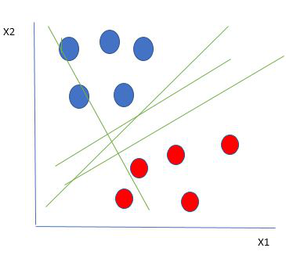
Linearly Separable Data points
From the figure above it’s very clear that there are multiple lines (our hyperplane here is a line because we are considering only two input features x₁, x₂) that segregate our data points or do a classification between red and blue circles. So how do we choose the best line or in general the best hyperplane that segregates our data points?

One reasonable choice as the best hyperplane is the one that represents the largest separation or margin between the two classes.
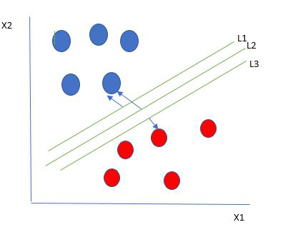
Multiple hyperplanes separate the data from two classes
So we choose the hyperplane whose distance from it to the nearest data point on each side is maximized. If such a hyperplane exists it is known as the maximum-margin hyperplane/hard margin. So from the above figure, we choose L2. Let’s consider a scenario like shown below
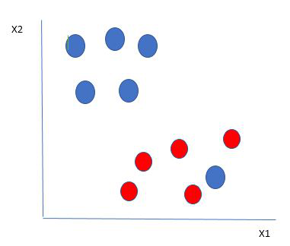
Selecting hyperplane for data with outlier
Here we have one blue ball in the boundary of the red ball. So how does SVM classify the data? It’s simple! The blue ball in the boundary of red ones is an outlier of blue balls. The SVM algorithm has the characteristics to ignore the outlier and finds the best hyperplane that maximizes the margin. SVM is robust to outliers.
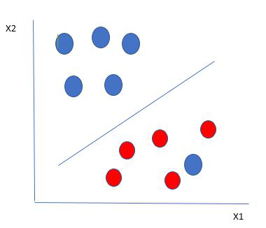
Hyperplane which is the most optimized one
So in this type of data point what SVM does is, finds the maximum margin as done with previous data sets along with that it adds a penalty each time a point crosses the margin. So the margins in these types of cases are called soft margins. When there is a soft margin to the data set, the SVM tries to minimize (1/margin+∧(∑penalty)). Hinge loss is a commonly used penalty. If no violations no hinge loss.If violations hinge loss proportional to the distance of violation.
Till now, we were talking about linearly separable data(the group of blue balls and red balls are separable by a straight line/linear line). What to do if data are not linearly separable?
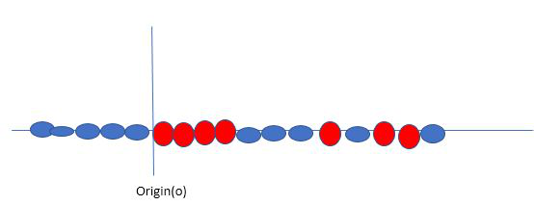
Original 1D dataset for classification
Say, our data is shown in the figure above. SVM solves this by creating a new variable using a kernel. We call a point x_{i} on the line and we create a new variable y_{i} as a function of distance from origin o.so if we plot this we get something like as shown below
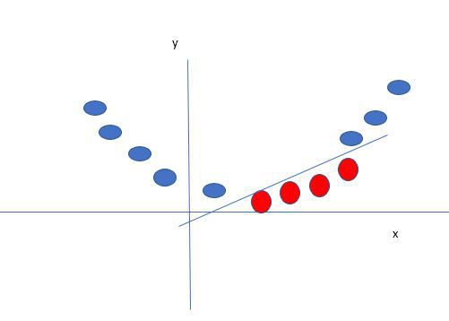
Mapping 1D data to 2D to become able to separate the two classes
In this case, the new variable y is created as a function of distance from the origin. A non-linear function that creates a new variable is referred to as a kernel.

Support Vector Machine Terminology
- Hyperplane: Hyperplane is the decision boundary that is used to separate the data points of different classes in a feature space. In the case of linear classifications, it will be a linear equation i.e. wx+b = 0.
- Support Vectors: Support vectors are the closest data points to the hyperplane, which makes a critical role in deciding the hyperplane and margin.
- Margin: Margin is the distance between the support vector and hyperplane. The main objective of the support vector machine algorithm is to maximize the margin. The wider margin indicates better classification performance.
- Kernel: Kernel is the mathematical function, which is used in SVM to map the original input data points into high-dimensional feature spaces, so, that the hyperplane can be easily found out even if the data points are not linearly separable in the original input space. Some of the common kernel functions are linear, polynomial, radial basis function(RBF), and sigmoid.
- Hard Margin: The maximum-margin hyperplane or the hard margin hyperplane is a hyperplane that properly separates the data points of different categories without any misclassifications.
- Soft Margin: When the data is not perfectly separable or contains outliers, SVM permits a soft margin technique. Each data point has a slack variable introduced by the soft-margin SVM formulation, which softens the strict margin requirement and permits certain misclassifications or violations. It discovers a compromise between increasing the margin and reducing violations.
- C: Margin maximisation and misclassification fines are balanced by the regularisation parameter C in SVM. The penalty for going over the margin or misclassifying data items is decided by it. A stricter penalty is imposed with a greater value of C, which results in a smaller margin and perhaps fewer misclassifications.
- Hinge Loss: A typical loss function in SVMs is hinge loss. It punishes incorrect classifications or margin violations. The objective function in SVM is frequently formed by combining it with the regularisation term.
- Dual Problem: A dual Problem of the optimisation problem that requires locating the Lagrange multipliers related to the support vectors can be used to solve SVM. The dual formulation enables the use of kernel tricks and more effective computing.

SVM implementation in Python
Predict if cancer is Benign or malignant. Using historical data about patients diagnosed with cancer enables doctors to differentiate malignant cases and benign ones are given independent attributes.

Steps
- Load the breast cancer dataset from sklearn.datasets
- Separate input features and target variables.
- Buil and train the SVM classifiers using RBF kernel.
- Plot the scatter plot of the input features.
- Plot the decision boundary.
- Plot the decision boundary
Example:
# Load the important packages
from sklearn.datasets import load_breast_cancer
import matplotlib.pyplot as plt
from sklearn.inspection import DecisionBoundaryDisplay
from sklearn.svm import SVC
# Load the datasets
cancer = load_breast_cancer()
X = cancer.data[:, :2]
y = cancer.target
#Build the model
svm = SVC(kernel="rbf", gamma=0.5, C=1.0)
# Trained the model
svm.fit(X, y)
# Plot Decision Boundary
DecisionBoundaryDisplay.from_estimator(
svm,
X,
response_method="predict",
cmap=plt.cm.Spectral,
alpha=0.8,
xlabel=cancer.feature_names[0],
ylabel=cancer.feature_names[1],
)
# Scatter plot
plt.scatter(X[:, 0], X[:, 1], c=y, s=20, edgecolors="k")
plt.show()
Output:
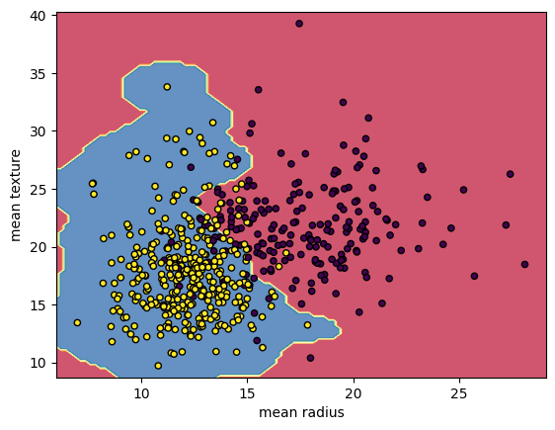
Breast Cancer Classifications with SVM RBF kernel
5.Naïve Bayes:
A Naive Bayes classifiers, a family of algorithms based on Bayes’ Theorem. Despite the “naive” assumption of feature independence, these classifiers are widely utilized for their simplicity and efficiency in machine learning. The article delves into theory, implementation, and applications, shedding light on their practical utility despite oversimplified assumptions.

What is Naive Bayes Classifiers?
Naive Bayes classifiers are a collection of classification algorithms based on Bayes’ Theorem. It is not a single algorithm but a family of algorithms where all of them share a common principle, i.e. every pair of features being classified is independent of each other. To start with, let us consider a dataset.
One of the most simple and effective classification algorithms, the Naïve Bayes classifier aids in the rapid development of machine learning models with rapid prediction capabilities.
Naïve Bayes algorithm is used for classification problems. It is highly used in text classification. In text classification tasks, data contains high dimension (as each word represent one feature in the data). It is used in spam filtering, sentiment detection, rating classification etc. The advantage of using naïve Bayes is its speed. It is fast and making prediction is easy with high dimension of data.This model predicts the probability of an instance belongs to a class with a given set of feature value. It is a probabilistic classifier. It is because it assumes that one feature in the model is independent of existence of another feature. In other words, each feature contributes to the predictions with no relation between each other. In real world, this condition satisfies rarely. It uses Bayes theorem in the algorithm for training and prediction

Why it is Called Naive Bayes?
The “Naive” part of the name indicates the simplifying assumption made by the Naïve Bayes classifier. The classifier assumes that the features used to describe an observation are conditionally independent, given the class label. The “Bayes” part of the name refers to Reverend Thomas Bayes, an 18th-century statistician and theologian who formulated Bayes’ theorem.
Consider a fictional dataset that describes the weather conditions for playing a game of golf. Given the weather conditions, each tuple classifies the conditions as fit(“Yes”) or unfit(“No”) for playing golf.Here is a tabular representation of our dataset.
The assumptions made by Naive Bayes are not generally correct in real-world situations. In-fact, the independence assumption is never correct but often works well in practice.Now, before moving to the formula for Naive Bayes, it is important to know about Bayes’ theorem.

Bayes’ Theorem
Bayes’ Theorem finds the probability of an event occurring given the probability of another event that has already occurred. Bayes’ theorem is stated mathematically as the following equation:
P(A∣B)=P(B)P(B∣A)P(A)​
where A and B are events and P(B) ≠ 0
- Basically, we are trying to find probability of event A, given the event B is true. Event B is also termed as evidence.
- P(A) is the priori of A (the prior probability, i.e. Probability of event before evidence is seen). The evidence is an attribute value of an unknown instance(here, it is event B).
- P(B) is Marginal Probability: Probability of Evidence.
- P(A|B) is a posteriori probability of B, i.e. probability of event after evidence is seen.
- P(B|A) is Likelihood probability i.e the likelihood that a hypothesis will come true based on the evidence.

Naive Bayes implementation in Python
# load the iris dataset
from sklearn.datasets import load_iris
iris = load_iris()
# store the feature matrix (X) and response vector (y)
X = iris.data
y = iris.target
# splitting X and y into training and testing sets
from sklearn.model_selection import train_test_split
X_train, X_test, y_train, y_test = train_test_split(X, y, test_size=0.4, random_state=1)
# training the model on training set
from sklearn.naive_bayes import GaussianNB
gnb = GaussianNB()
gnb.fit(X_train, y_train)
# making predictions on the testing set
y_pred = gnb.predict(X_test)
# comparing actual response values (y_test) with predicted response values (y_pred)
from sklearn import metrics
print("Gaussian Naive Bayes model accuracy(in %):", metrics.accuracy_score(y_test, y_pred)*100)
OUTPUT: Gaussian Naive Bayes model accuracy(in %): 95.0

5.2 Sample Code:
VictimDetection.py
from tkinter import *
import tkinter
from tkinter import filedialog
import matplotlib.pyplot as plt
from tkinter.filedialog import askopenfilename
from sklearn.tree import DecisionTreeClassifier
from sklearn.feature_selection import SelectFromModel
import seaborn as sns
import os
from sklearn.metrics import confusion_matrix
import cv2
import numpy as np
from keras.utils.np_utils import to_categorical
from keras.layers import MaxPooling2D
from keras.layers import Dense, Dropout, Activation, Flatten, GlobalAveragePooling2D, BatchNormalization
from keras.layers import Convolution2D
from keras.models import Sequential, load_model, Model
import pickle
from sklearn.metrics import precision_score
from sklearn.metrics import recall_score
from sklearn.metrics import f1_score
from sklearn.metrics import accuracy_score
from sklearn.model_selection import train_test_split
from keras.callbacks import ModelCheckpoint
import keras
from sklearn.metrics import accuracy_score
from sklearn.model_selection import train_test_split
from keras.applications import ResNet50
from sklearn.neural_network import MLPClassifier
from sklearn import svm
from sklearn.ensemble import RandomForestClassifier
import xgboost as xg
import pandas as pd

main = tkinter.Tk()
main.title("A Novel Approach for Disaster Victim Detection Under Debris Environments Using Decision Tree Algorithms With Deep Learning Features")
main.geometry("1200x1200")

labels = ['Body', 'Hand', 'Leg']
global filename, X, Y, X_train, y_train, X_test, y_test
global resnet_model, accuracy, precision, recall, fscore, resnet_features
global X_train, X_test, y_train, y_test

def getLabel(name):
index = -1
for i in range(len(labels)):
if labels[i] == name:
index = i
break
return index

def uploadDataset():
global filename, X, Y
filename = filedialog.askdirectory(initialdir=".")
pathlabel.config(text=filename)
text.delete('1.0', END)
text.insert(END,filename+" loaded\n\n")
if os.path.exists('model/X.txt.npy'):
X = np.load('model/X.txt.npy')
Y = np.load('model/Y.txt.npy')
else:
X = []
Y = []
for root, dirs, directory in os.walk(path):
for j in range(len(directory)):
name = os.path.basename(root)
if 'Thumbs.db' not in directory[j]:
img = cv2.imread(root+"/"+directory[j])
img = cv2.resize(img, (32, 32))
X.append(img)
label = getLabel(name)
Y.append(label)
X = np.asarray(X)
Y = np.asarray(Y)
np.save('model/X.txt',X)
np.save('model/Y.txt',Y)
text.insert(END,"Total images loaded = "+str(X.shape[0])+"\n")
text.insert(END,"Victim Parts Found in Dataset : "+str(labels))
unique, count = np.unique(Y, return_counts = True)
height = count
bars = labels
y_pos = np.arange(len(bars))
plt.figure(figsize=(6,3))
plt.bar(y_pos, height)
plt.xticks(y_pos, bars)
plt.xlabel("Victim Dataset Graphs")
plt.ylabel("Count")
plt.title("Dataset Class Label Graph")
plt.tight_layout()
plt.show()

def processDataset():
global X, Y
text.delete('1.0', END)
X = X.astype('float32')
X = X/255
indices = np.arange(X.shape[0])
np.random.shuffle(indices)
X = X[indices]
Y = Y[indices]
Y = to_categorical(Y)
text.insert(END,"Images pixels shuffling & normalizations completed\n\n")
text.insert(END,"Total features found in each image = "+str(X.shape[1] * X.shape[2] * X.shape[3])+"\n\n")

def featuresExtraction():
global X, Y, resnet_model, resnet_features
resnet_model = ResNet50(input_shape=(X.shape[1], X.shape[2], X.shape[3]), include_top=False, weights='imagenet')
for layer in resnet_model.layers:
layer.trainable = False
resnet_model = Sequential()
resnet_model.add(Convolution2D(32, (3, 3), input_shape = (X.shape[1], X.shape[2], X.shape[3]), activation = 'relu'))
resnet_model.add(MaxPooling2D(pool_size = (2, 2)))
resnet_model.add(Convolution2D(32, (3, 3), activation = 'relu'))
resnet_model.add(MaxPooling2D(pool_size = (2, 2)))
resnet_model.add(Flatten())
resnet_model.add(Dense(units = 256, activation = 'relu'))
resnet_model.add(Dense(units = Y.shape[1], activation = 'softmax'))
resnet_model.compile(optimizer = 'adam', loss = 'categorical_crossentropy', metrics = ['accuracy'])
if os.path.exists("model/resnet_weights.hdf5") == False:
model_check_point = ModelCheckpoint(filepath='model/resnet_weights.hdf5', verbose = 1, save_best_only = True)
hist = resnet_model.fit(X, Y, batch_size = 32, epochs = 20, validation_data=(X, Y), callbacks=[model_check_point], verbose=1)
f = open('model/resnet_history.pckl', 'wb')
pickle.dump(hist.history, f)
f.close()
else:
resnet_model.load_weights("model/resnet_weights.hdf5")
resnet_features = Model(resnet_model.inputs, resnet_model.layers[-2].output)#create resnet model
resnet_features = resnet_features.predict(X) #extracting resnet features
Y = np.argmax(Y, axis=1)
text.insert(END,"Total features extracted by ResNet50 from each Image : "+str(resnet_features.shape[1])+"\n\n")

def featuresSelection():
global resnet_features, Y
global X_train, X_test, y_train, y_test
dt_cls = DecisionTreeClassifier()
selector = SelectFromModel(dt_cls, threshold=0.00000005)
selector.fit(resnet_features, Y)#train algorithm using training features and target value
selected_features = selector.get_support()
resnet_features = resnet_features[:,selected_features] #extract selected features
text.insert(END,"Total features selected by Decision Tree (J48) Algorithm : "+str(resnet_features.shape[1])+"\n\n")
X_train, X_test, y_train, y_test = train_test_split(resnet_features, Y, test_size=0.2)
text.insert(END,"Dataset Training & Testing Details\n\n")
text.insert(END,"80% images for training : "+str(X_train.shape[0])+"\n")
text.insert(END,"20% images for testing : "+str(X_test.shape[0])+"\n")

#function to calculate all metrics
def calculateMetrics(algorithm, testY, predict):
global labels
p = precision_score(testY, predict,average='macro') * 100
r = recall_score(testY, predict,average='macro') * 100
f = f1_score(testY, predict,average='macro') * 100
a = accuracy_score(testY,predict)*100
accuracy.append(a)
precision.append(p)
recall.append(r)
fscore.append(f)
text.insert(END,algorithm+" Accuracy : "+str(a)+"\n")
text.insert(END,algorithm+" Precision : "+str(p)+"\n")
text.insert(END,algorithm+" Recall : "+str(r)+"\n")
text.insert(END,algorithm+" FSCORE : "+str(f)+"\n\n")
conf_matrix = confusion_matrix(testY, predict)
plt.figure(figsize =(6, 3))
ax = sns.heatmap(conf_matrix, xticklabels = labels, yticklabels = labels, annot = True, cmap="viridis" ,fmt ="g");
ax.set_ylim([0,len(labels)])
plt.title(algorithm+" Confusion matrix")
plt.xticks(rotation=90)
plt.ylabel('True class')
plt.xlabel('Predicted class')
plt.show()

def runSVM():
global X_train, X_test, y_train, y_test
global accuracy, precision, recall, fscore
text.delete('1.0', END)
accuracy = []
precision = []
recall = []
fscore = []
svm_cls = svm.SVC(C=102.0, tol=1.9)
svm_cls.fit(X_train, y_train)
predict = svm_cls.predict(X_test)
calculateMetrics("SVM", y_test, predict)

def runRandomForest():
rf_cls = RandomForestClassifier()
rf_cls.fit(X_train, y_train)
predict = rf_cls.predict(X_test)
calculateMetrics("Random Forest", y_test, predict)

def runNaiveBayes():
mlp_cls = MLPClassifier(hidden_layer_sizes=2)
mlp_cls.fit(X_train, y_train)
predict = mlp_cls.predict(X_test)
calculateMetrics("MLP", y_test, predict)

def runExtension():
global accuracy, precision, recall, fscore, X_train, X_test, y_train, y_test
X_train, X_test1, y_train, y_test1 = train_test_split(resnet_features, Y, test_size=0.1)
xg_model = xg.XGBClassifier() #create XGBOost object
xg_model.fit(X_train, y_train)
predict = xg_model.predict(X_test)
calculateMetrics("Extension XGBoost", y_test, predict)

def graph():
global accuracy, precision, recall, fscore, rmse
df = pd.DataFrame([['SVM','Precision',precision[0]],['SVM','Recall',recall[0]],['SVM','F1 Score',fscore[0]],['SVM','Accuracy',accuracy[0]],
['Random Forest','Precision',precision[1]],['Random Forest','Recall',recall[1]],['Random Forest','F1 Score',fscore[1]],['Random Forest','Accuracy',accuracy[1]],
['Naive Bayes','Precision',precision[2]],['Naive Bayes','Recall',recall[2]],['Naive Bayes','F1 Score',fscore[2]],['Naive Bayes','Accuracy',accuracy[2]],
['Extension XGBoost','Precision',precision[3]],['Extension XGBoost','Recall',recall[3]],['Extension XGBoost','F1 Score',fscore[3]],['Extension XGBoost','Accuracy',accuracy[3]],
],columns=['Algorithms','Performance Output','Value'])
df.pivot("Algorithms", "Performance Output", "Value").plot(kind='bar')
plt.show()

def predict():
global resnet_model, labels
filename = filedialog.askopenfilename(initialdir="testImages")
pathlabel.config(text=filename)
text.delete('1.0', END)
img = cv2.imread(filename)
img = cv2.resize(img, (32,32))#resize image
im2arr = np.array(img)
im2arr = im2arr.reshape(1,32,32,3)
img = np.asarray(im2arr)
img = img.astype('float32')
img = img/255 #normalizing test image
predict = resnet_model.predict(img)#now using cnn model to detcet tumor damage
predict = np.argmax(predict)
img = cv2.imread(filename)
img = cv2.resize(img, (600,400))
cv2.putText(img, 'Victim Part Detected : '+labels[predict], (100, 25), cv2.FONT_HERSHEY_SIMPLEX,0.7, (0, 0, 255), 2)
cv2.imshow("Predicted Output", img)
cv2.waitKey(0)

font = ('times', 15, 'bold')
title = Label(main, text='A Novel Approach for Disaster Victim Detection Under Debris Environments Using Decision Tree Algorithms With Deep Learning Features')
title.config(bg='brown', fg='white')
title.config(font=font)
title.config(height=3, width=120)
title.place(x=30,y=5)

font1 = ('times', 13, 'bold')
upload = Button(main, text="Upload Victim Detection Dataset", command=uploadDataset)
upload.place(x=50,y=100)
upload.config(font=font1)

pathlabel = Label(main)
pathlabel.config(bg='brown', fg='white')
pathlabel.config(font=font1)
pathlabel.place(x=480,y=100)

processButton = Button(main, text="Features Processing & Normalizaton", command=processDataset)
processButton.place(x=50,y=150)
processButton.config(font=font1)

resnetButton = Button(main, text="Extract Features from ResNet50", command=featuresExtraction)
resnetButton.place(x=350,y=150)
resnetButton.config(font=font1)

dtButton = Button(main, text="Features Selection Decision Tree", command=featuresSelection)
dtButton.place(x=650,y=150)
dtButton.config(font=font1)

svmButton = Button(main, text="Run SVM Algorithm", command=runSVM)
svmButton.place(x=50,y=200)
svmButton.config(font=font1)

rfButton = Button(main, text="Run Random Forest", command=runRandomForest)
rfButton.place(x=350,y=200)
rfButton.config(font=font1)

nbButton = Button(main, text="Run MLP Algorithm", command=runNaiveBayes)
nbButton.place(x=650,y=200)
nbButton.config(font=font1)

xgboostButton = Button(main, text="Run Extension XGBoost", command=runExtension)
xgboostButton.place(x=50,y=250)
xgboostButton.config(font=font1)

graphButton = Button(main, text="Comparison Graph", command=graph)
graphButton.place(x=350,y=250)
graphButton.config(font=font1)

predictButton = Button(main, text="Victim Detection from Test Image", command=predict)
predictButton.place(x=650,y=250)
predictButton.config(font=font1)

font1 = ('times', 12, 'bold')
text=Text(main,height=20,width=150)
scroll=Scrollbar(text)
text.configure(yscrollcommand=scroll.set)
text.place(x=10,y=300)
text.config(font=font1)

main.config(bg='brown')
main.mainloop()
6. TESTING
Implementation and Testing:
Implementation is one of the most important tasks in project is the phase in which one has to be cautions because all the efforts undertaken during the project will be very interactive. Implementation is the most crucial stage in achieving successful system and giving the users confidence that the new system is workable and effective. Each program is tested individually at the time of development using the sample data and has verified that these programs link together in the way specified in the program specification. The computer system and its environment are tested to the satisfaction of the user.
Implementation
The implementation phase is less creative than system design. It is primarily concerned with user training, and file conversion. The system may be requiring extensive user training. The initial parameters of the system should be modifies as a result of a programming. A simple operating procedure is provided so that the user can understand the different functions clearly and quickly. The different reports can be obtained either on the inkjet or dot matrix printer, which is available at the disposal of the user. The proposed system is very easy to implement. In general implementation is used to mean the process of converting a new or revised system design into an operational one.

Testing
Testing is the process where the test data is prepared and is used for testing the modules individually and later the validation given for the fields. Then the system testing takes place which makes sure that all components of the system property functions as a unit. The test data should be chosen such that it passed through all possible condition. Actually testing is the state of implementation which aimed at ensuring that the system works accurately and efficiently before the actual operation commence. The following is the description of the testing strategies, which were carried out during the testing period.

System Testing
Testing has become an integral part of any system or project especially in the field of information technology. The importance of testing is a method of justifying, if one is ready to move further, be it to be check if one is capable to with stand the rigors of a particular situation cannot be underplayed and that is why testing before development is so critical. When the software is developed before it is given to user to use the software must be tested whether it is solving the purpose for which it is developed. This testing involves various types through which one can ensure the software is reliable. The program was tested logically and pattern of execution of the program for a set of data are repeated. Thus the code was exhaustively checked for all possible correct data and the outcomes were also checked.

Module Testing
To locate errors, each module is tested individually. This enables us to detect error and correct it without affecting any other modules. Whenever the program is not satisfying the required function, it must be corrected to get the required result. Thus all the modules are individually tested from bottom up starting with the smallest and lowest modules and proceeding to the next level. Each module in the system is tested separately. For example the job classification module is tested separately. This module is tested with different job and its approximate execution time and the result of the test is compared with the results that are prepared manually. The comparison shows that the results proposed system works efficiently than the existing system. Each module in the system is tested separately. In this system the resource classification and job scheduling modules are tested separately and their corresponding results are obtained which reduces the process waiting time.
Integration Testing
After the module testing, the integration testing is applied. When linking the modules there may be chance for errors to occur, these errors are corrected by using this testing. In this system all modules are connected and tested. The testing results are very correct. Thus the mapping of jobs with resources is done correctly by the system.
Acceptance Testing
When that user fined no major problems with its accuracy, the system passers through a final acceptance test. This test confirms that the system needs the original goals, objectives and requirements established during analysis without actual execution which elimination wastage of time and money acceptance tests on the shoulders of users and management, it is finally acceptable and ready for the operation
Test Case Id | Test Case Name | Test Case Desc. | Test Steps |  |  | Test Case Status | Test Priority
 |  |  | Step | Expected | Actual
01 | Upload Dataset | Test whether Dataset is uploaded or not into the system | If the Dataset may not uploaded | We cannot do further operations | Dataset uploaded we will do further operations | High | High
02 | Preprocess& Normalized Dataset | Test whether the Pre-process & Normalized Dataset Successfully or not | If the Pre-process & Normalized Dataset may not Run Successfully | We cannot do further operations | we will do further  operations | High | High
03 | Features Extraction | Test whether features Extraction Run Successfully or not | If the  Features Extraction may not Run Successfully | We cannot do further operations | we will do further  operations | High | High
04 | Run SVM Algorithm | Test whether run SVM Successfully or not | If the SVM Algorithm may not Run Successfully | We cannot do further operations | we will do further  operations | High | High
05 | Run Random Forest Algorithm | Test whether Random Forest Algorithm Run Successfully or not | If the  Random Forest Algorithm may not Run Successfully | We cannot do further operations | we will do further  operations | High | High
06 | Run Naive bayes | Test whether Naive bayes Run Successfully or not | If the  NaiveBayes may not Run Successfully | We cannot do further operations | we will do further  operations | High | High
07 | Run XGBOOST Regression | Test whether XGBOOST Run Successfully or not | If the XGBOOST may not Run Successfully | We cannot do further operations | we will do further  operations | High | High
08 | Comparison Graph | Test whether Comparison Graph Successfully or not | If the  Comparison Graph may not Run Successfully | We cannot do further operations | we will do further  operations | High | High
09 | Predict from Test Data | Test whether Predict from Test Data Successfully or not | If the  Predict from Test Data may not Run Successfully | We cannot do further operations | we will do further  operations | High | High

7.SCREENSHOTS:
To run project double click on run.bat file to get below screen
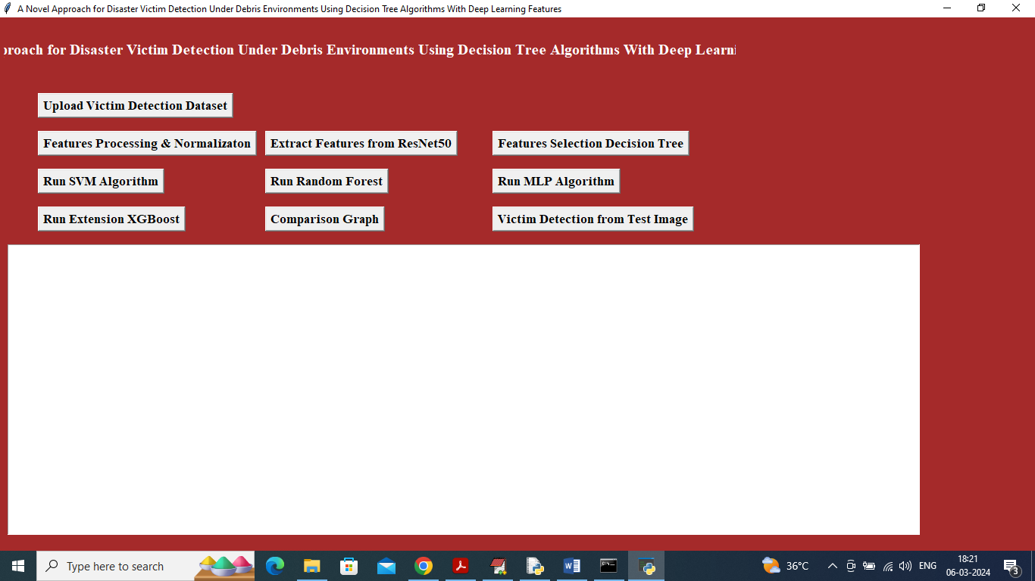
In above screen click on ‘Upload Victim Detection Dataset’ button to upload dataset and get below output
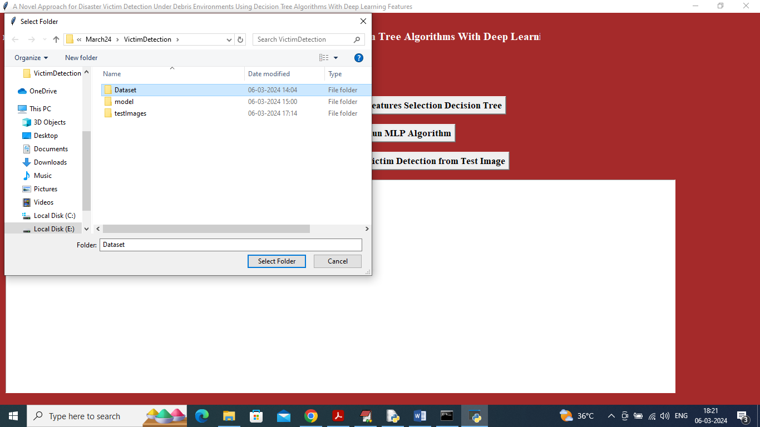
In above screen selecting and uploading Dataset and then click on ‘Select Folder’ button to load dataset and get below page
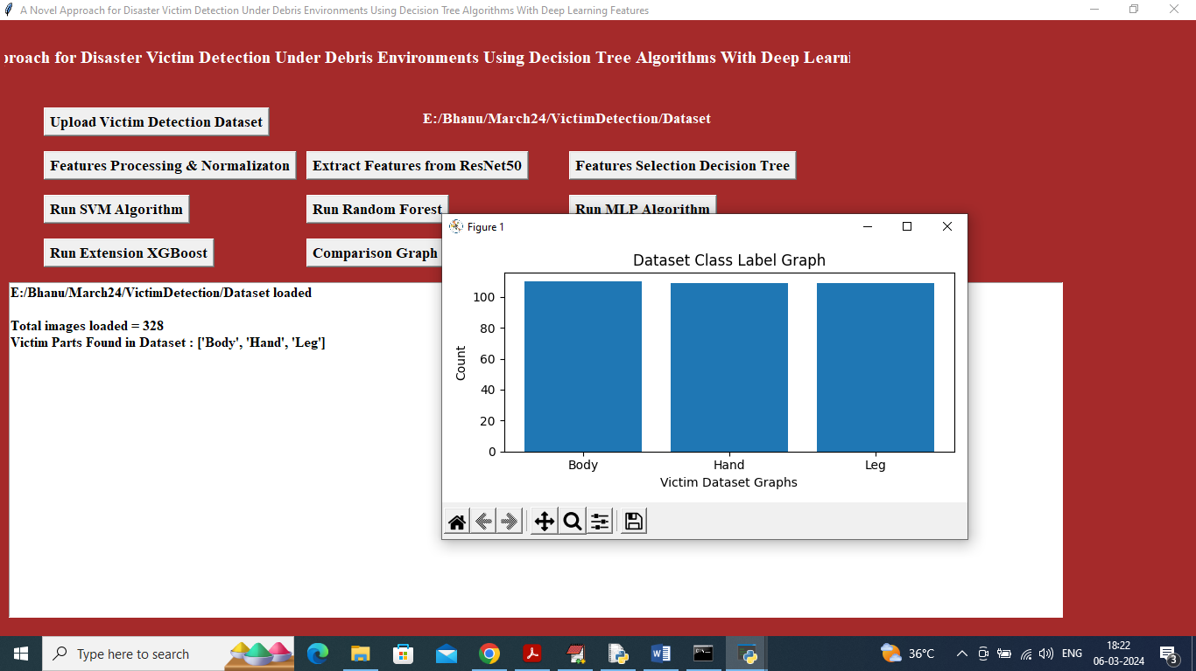
In above screen can see dataset contains 328 images of various part labels and in graph x-axis represents victim part names and y-axis represents count of images under that category and now close above graph and then click on ‘Features Processing & Normalization’ to process features and get below page
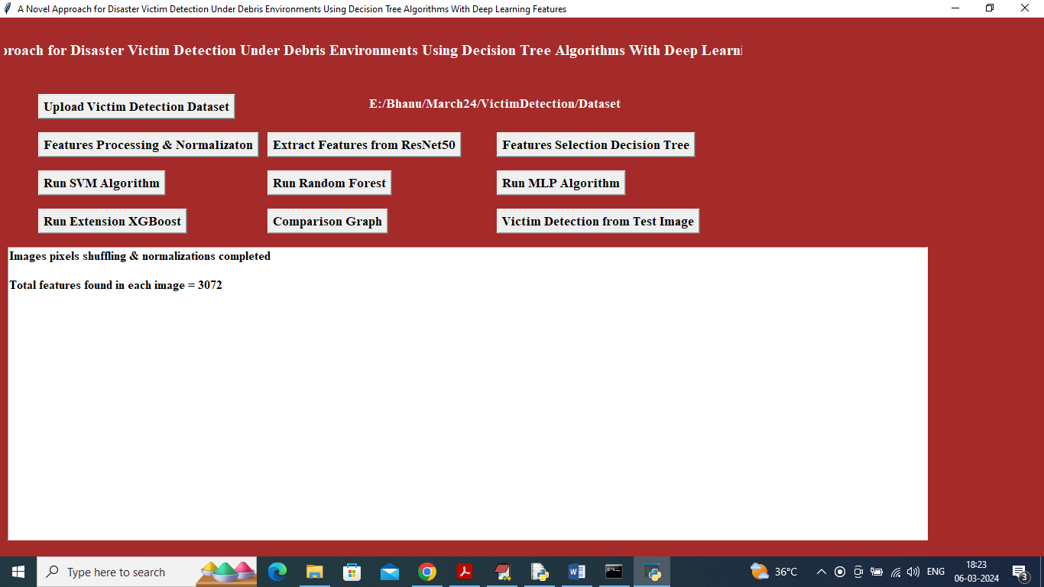
In above screen application read 3072 features from each image and then input this features to ResNet50 algorithm to extract features and get below page
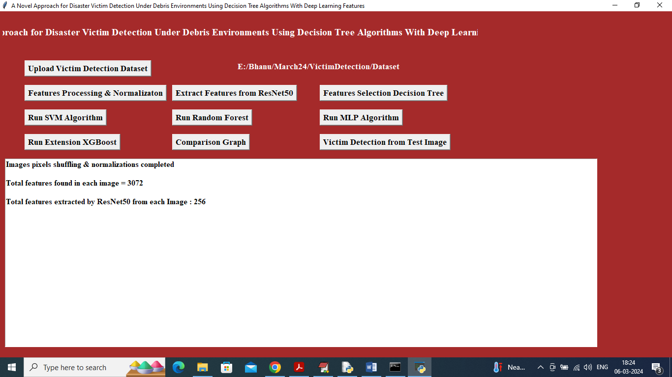
In above screen Resnet50 extracted relevant 256 features from given 3072 original features and now click on ‘Features Selection Decision Tree’ button to select relevant features out of 256
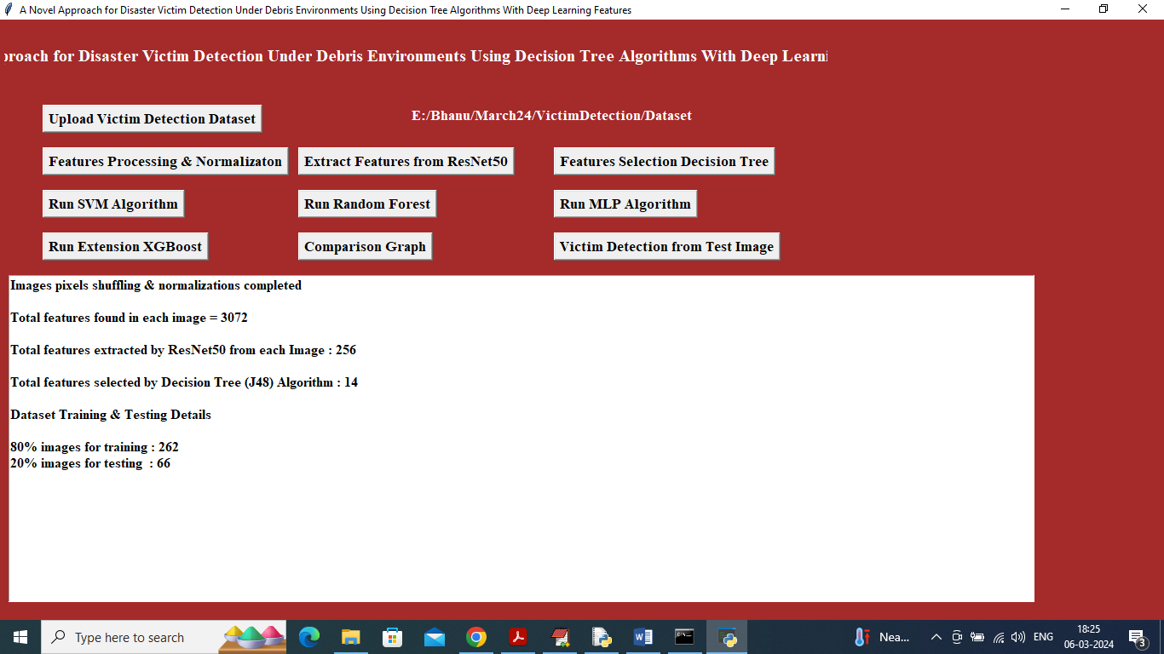
In above screen from 256 J48 Decision Tree selected 14 features and then can see Train and test size and now click on ‘Run SVM Algorithm’ button to get below page
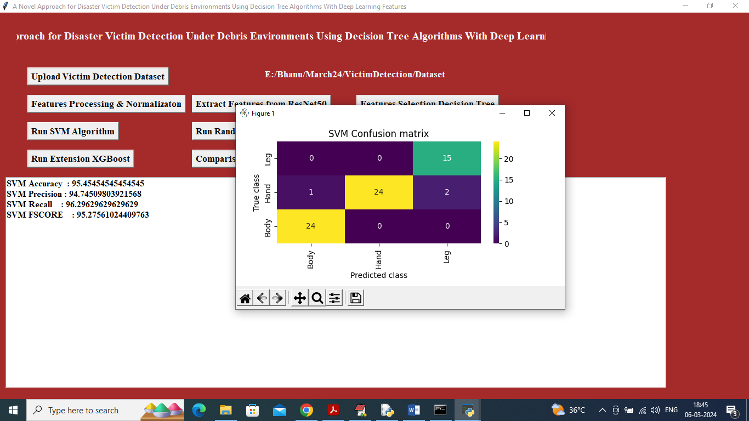
In above screen SVM training completed and it got 95% accuracy on test images and can see other metrics like precision, recall and FSCORE. In confusion matrix graph x-axis represents Predicted Labels and y-axis represents true labels and then all different colour boxes in diagnol represents correct prediction count and remaining all blue boxes contains incorrect prediction count. Now click on ‘Run Random Forest’ button to get below output
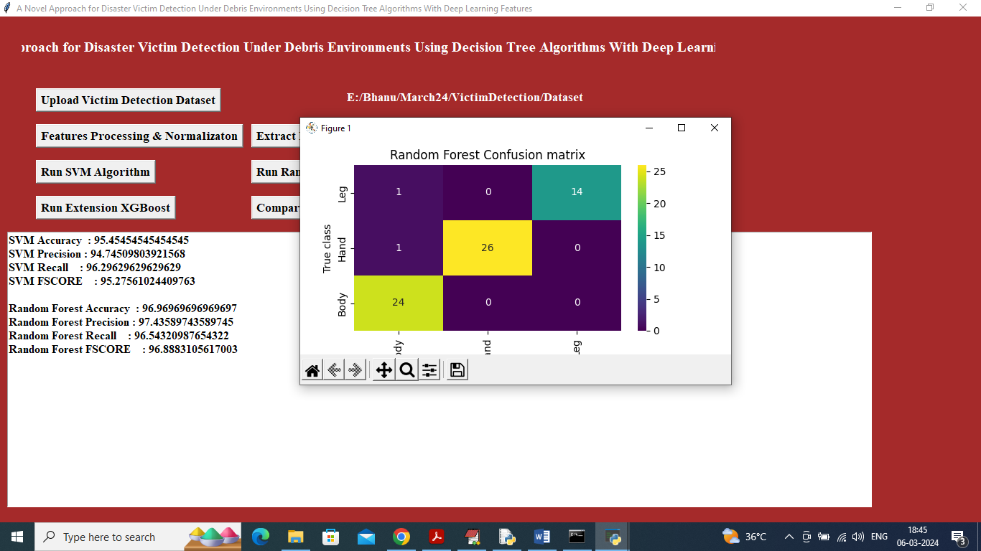
In above screen Random Forest also got 96% accuracy and now click on ‘Run MLP Algorithm’ button to get below output

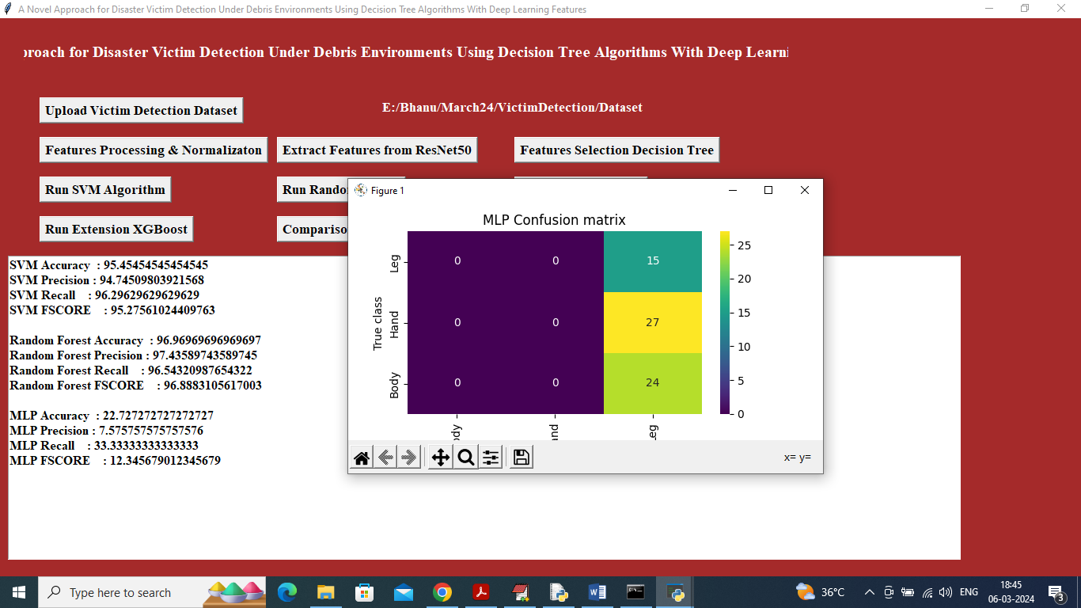
In above screen MLP got 22% accuracy and now click on ‘Run Extension Algorithm’ button to get below output
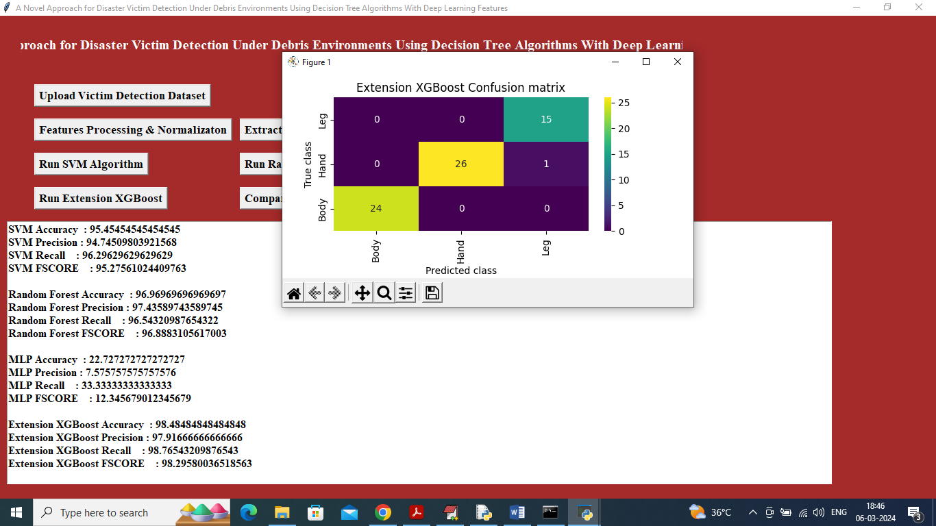
In above screen extension XGBOOST got 98% accuracy and can click on ‘Comparison Graph’ button to get below graph
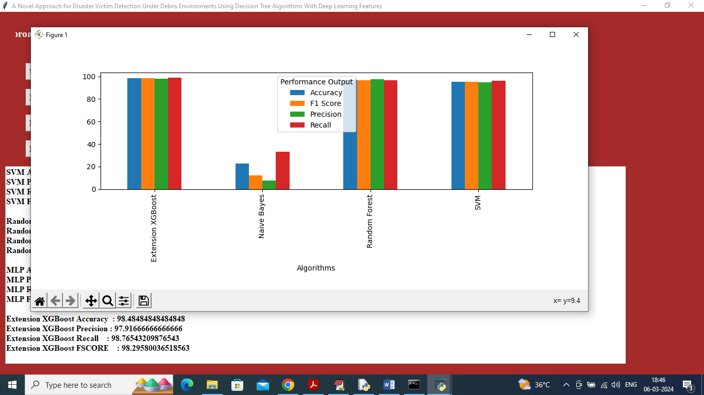
In above screen x-axis represents algorithm names and y-axis represents accuracy and other metrics in different colour and in all algorithms XGBOOST got high accuracy and now click on ‘Victim Detection from Test Image’ button to upload test image and get below output
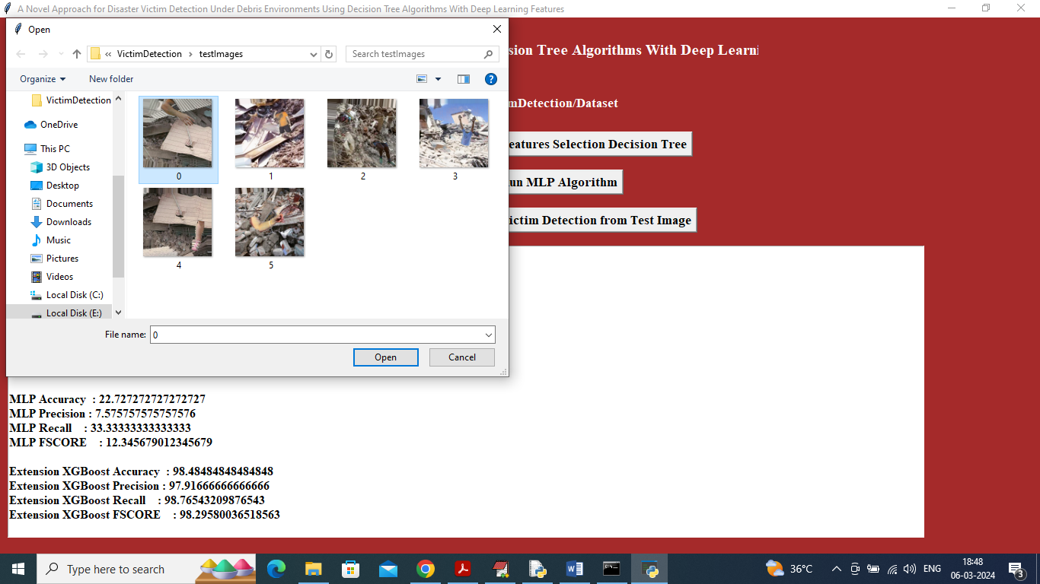
In above screen selecting and uploading 0.jpg file and then click on ‘Open’ button to get below output
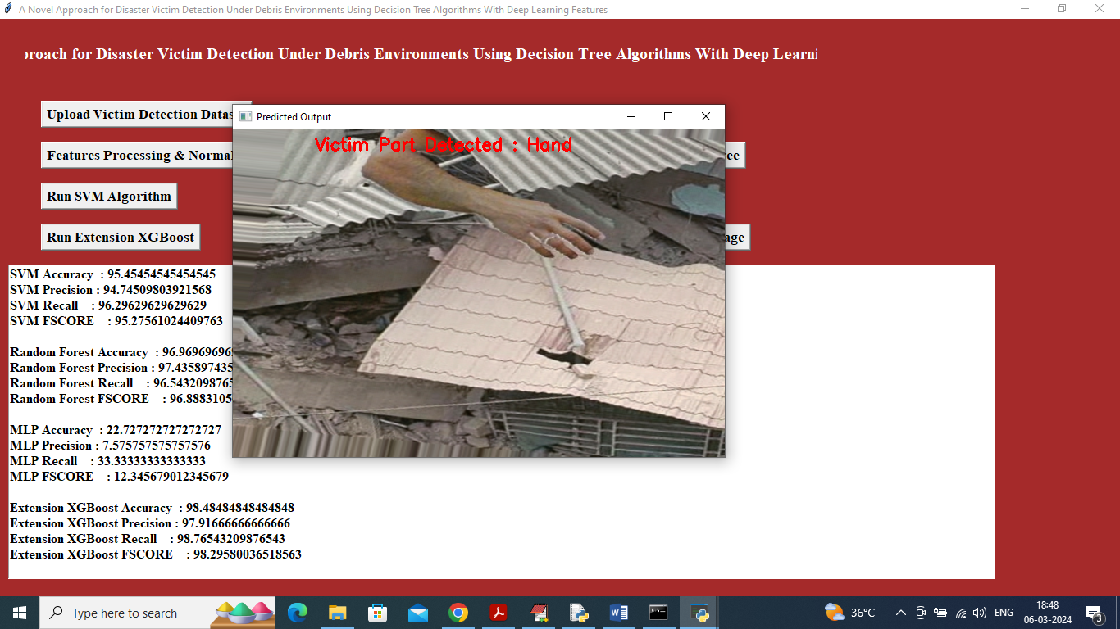
In above screen in red colour text can see victim part detected as HAND and similarly you can upload and test other images
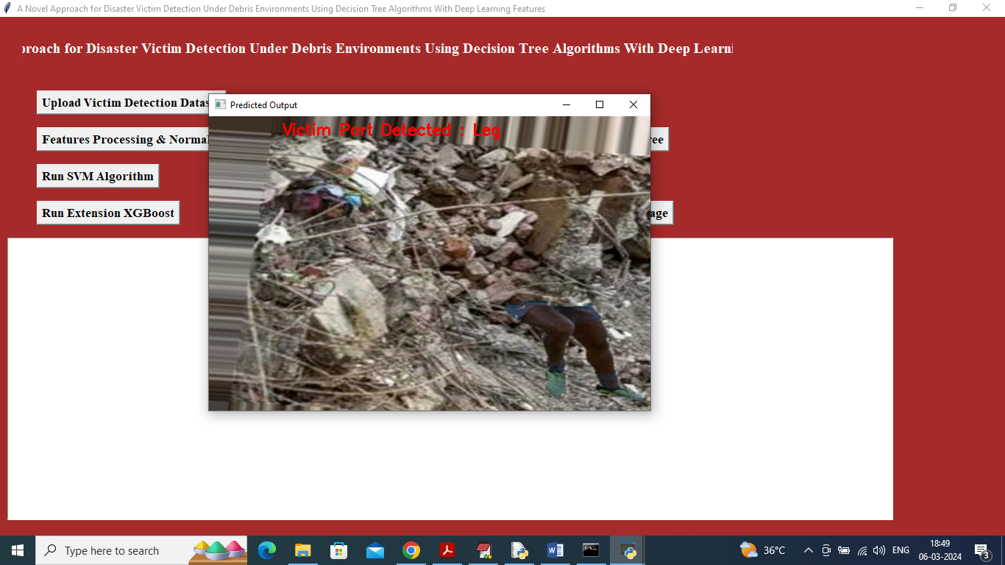
In above screen leg is detected
8. CONCLUSION:
This paper proposes a novel approach for disaster victim detection under debris environments using decision tree algorithms with deep learning features on a custom-made Human Victim Detection (HVD) dataset. This model aims to assist Urban Search and Rescue (USAR) teams in quickly finding human casualties in areas with collapsed buildings. The five categories of HVD images were head, hand, leg, whole body, and without the body. The HVD dataset was pre-processed with several data augmentation functions to increase the dataset’s size based on the application conditions, and it was subsequently downsized to fit with the pre-trained ResNet-50 network’s input requirements. To enhance the feature learning procedure, fine-tuning-based transfer learning was applied. The learned features were removed, and only the significant characteristics were selected for additional classifications based on machine learning. Random trees outperformed all other classifiers. Finally, it can be concluded that integrating the TL-based CNN features with ML classifiers can significantly improve classification performance. More accuracy in a shorter amount of time is ensured by the feature extraction method employing pre-trained ResNet-50. A maximum classification accuracy of 99.53% for all five test classes is provided using random tree methods in 0.02s. The results show that the proposed approach is feasible and reliable regarding accuracy and computation time. Though transfer learning is a promising expansion in the field of DL, helping learn features even from small datasets from the knowledge obtained from huge datasets, the proposed Human Victim Detection Approach (HVDA) dataset could be expanded further to include the maximum possible images.
9. REFERENCES:
[1] D. E. Alexander, Principles of Emergency Planning and Management. Oxford, U.K.: Oxford Univ. Press, 2002.
[2] G. Seeja, A. S. A. Doss, and V. B. Hency, ‘‘A survey on snake robot locomotion,’’ IEEE Access, vol. 10, pp. 112100–112116, 2022.
[3] A. Fung, L. Y. Wang, K. Zhang, G. Nejat, and B. Benhabib, ‘‘Using deep learning to find victims in unknown cluttered urban search and rescue environments,’’ Current Robot. Rep., vol. 1, no. 3, pp. 105–115, Sep. 2020.
[4] H. Liu, J. Liu, W. Yang, J. Chen, and M. Zhu, ‘‘Analysis and prediction of land use in Beijing–Tianjin–Hebei region: A study based on the improved convolutional neural network model,’’ Sustainability, vol. 12, no. 7, p. 3002, Apr. 2020, doi: 10.3390/su12073002.
[5] J. Zhang, S. Chen, R. Zhan, J. Hu, and J. Zhang, ‘‘Feature fusion based on convolutional neural network for SAR ATR,’’ in Proc. ITM Web Conf., 2017, p. 05001, doi: 10.1051/itmconf/20171205001.
[6] T. Arias-Vergara, P. Klumpp, J. C. Vasquez-Correa, E. Nöth, J. R. OrozcoArroyave, and M. Schuster, ‘‘Multi-channel spectrograms for speech processing applications using deep learning methods,’’ Pattern Anal. Appl., vol. 24, no. 2, pp. 423–431, May 2021.
[7] N. Lopac, F. Hržic, I. P. Vuksanovic, and J. Lerga, ‘‘Detection of non-stationary GW signals in high noise from Cohen’s class of timefrequency representations using deep learning,’’ IEEE Access, vol. 10, pp. 2408–2428, 2022.
[8] R. K. Samala, H.-P. Chan, L. M. Hadjiiski, M. A. Helvie, K. H. Cha, and C. D. Richter, ‘‘Multi-task transfer learning deep convolutional neural network: Application to computer-aided diagnosis of breast cancer on mammograms,’’ Phys. Med. Biol., vol. 62, no. 23, pp. 8894–8908, Nov. 2017, doi: 10.1088/1361-6560/aa93d4.
[9] G. De Cubber and G. Marton, ‘‘Human victim detection,’’ in Proc. 3rd Int. Workshop Robot. Risky Intervent. Environ. Surveill.-Maintenance (RISE), Jan. 2009.
[10] A. Kleiner, B. Steder, C. Dornhege, D. Höfer, D. Meyer-Delius, J. Prediger, J. Stückler, K. Glogowski, M. Thurner, M. Luber, M. Schnell, R. Kuemmerle, T. Burk, T. Bräuer, and B. Nebel, ‘‘RoboCupRescue— Robot league team RescueRobots Freiburg (Germany),’’ in Proc. RoboCup (CDROM), 2005, pp. 1–17.
[11] A. Visser, B. Slamet, T. Schmits, L. A. G. Jaime, A. Ethembabaoglu, and M. EarthquakeDisaster, ‘‘Design decisions of the UvA rescue 2007 team on the challenges of the virtual robot competition,’’ in Proc. 4th Int. Workshop Synth. Simul. Robot. Mitigate Earthq. Disaster, 2007, pp. 20–26.
[12] A. Birk, S. Markov, I. Delchev, and K. Pathak, ‘‘Autonomous rescue operations on the IUB rugbot,’’ in Proc. IEEE Int. Workshop Saf., Secur., Rescue Robot. (SSRR). IEEE Press, 2006.
[13] I. R. Nourbakhsh, K. Sycara, M. Koes, M. Yong, M. Lewis, and S. Burion, ‘‘Human–robot teaming for search and rescue,’’ IEEE Pervasive Comput., vol. 4, no. 1, pp. 72–79, Jan./Mar. 2005.
[14] D. R. Hartawan, T. W. Purboyo, and C. Setianingsih, ‘‘Disaster victims detection system using convolutional neural network (CNN) method,’’ in Proc. IEEE Int. Conf. Artif. Intell., Commun. Technol. (IAICT), Jul. 2019, pp. 105–111.
[15] N. Sharma, V. Jain, and A. Mishra, ‘‘An analysis of convolutional neural networks for image classification,’’ Proc. Comput. Sci., 132, pp. 377–384, Jan. 2018.
[16] A. Krizhevsky, I. Sutskever, and G. E. Hinton, ‘‘ImageNet classification with deep convolutional neural networks,’’ Commun. ACM, vol. 60, no. 6, pp. 84–90, May 2017.
[17] D. Han, Q. Liu, and W. Fan, ‘‘A new image classification method using CNN transfer learning and web data augmentation,’’ Exp. Syst. Appl., vol. 95, pp. 43–56, Apr. 2018.
[18] M. Hussain, J. J. Bird, and D. R. Faria, ‘‘A study on CNN transfer learning for image classification,’’ in Proc. UK Workshop Comput. Intell. Cham, Switzerland: Springer, 2018, pp. 191–202.
[19] E. Rezende, G. Ruppert, T. Carvalho, F. Ramos, and P. de Geus, ‘‘Malicious software classification using transfer learning of ResNet-50 deep neural network,’’ in Proc. 16th IEEE Int. Conf. Mach. Learn. Appl. (ICMLA), Dec. 2017, pp. 1011–1014.

